AUTOMATIC CLASSIFICATION OF CRIME-RELATED TEXT REPORTS USING NLP
CHAPTERS III, IV & V
Methodology | Implementation and Results | Discussion and Conclusion
YAASIIN MOHAMUUD ABDULLAAHI
NAIMA ABDIAZIZ SAID
NASTEHA MOHAMUUD MOHAMED
NAJMA MUHIDIIN MOHAMED

JAMHURIYA UNIVERSITY OF SCIENCE AND TECHNOLOGY (JUST)
FACULTY OF COMPUTER & INFORMATION TECHNOLOGY
AUGUST 2026

CONTENTS
CHAPTER III: METHODOLOGY 1
3.1 Introduction 1
3.2 System Overview 2
3.3 System Features 2
3.4 System Architecture 4
3.5 Data Acquisition and Preprocessing 5
3.6 Feature Engineering / Representation 6
3.7 Model / Algorithm Development 7
3.8 Requirements 9
3.9 Feasibility Study 11
3.10 System Design 12
CHAPTER IV: IMPLEMENTATION AND RESULTS 14
4.1 Dataset Description 14
4.2 ML Pipeline Implementation 15
4.3 System Design and Deployment 16
4.4 Data Visualization (Results Presentation) 19
4.5 Model Comparison 21
CHAPTER V: DISCUSSION AND CONCLUSION 23
5.1 Introduction 23
5.2 Interpretation of Results 23
5.3 Contribution to Knowledge 24
5.4 Challenges and Limitations 25
5.5 Future Work 25
5.6 Final Conclusion 26
APPENDIX A: FIGURE INDEX 28
APPENDIX B: TABLE INDEX 29
REFERENCES 30

CHAPTER THREE: METHODOLOGY

3.1 Introduction
This chapter presents the methodology used to design and develop BAREAI, an Artificial Intelligence based platform for the automatic classification of crime-related text reports using Natural Language Processing (NLP). The chapter describes the system overview, features, architecture, data acquisition and preprocessing procedures, feature engineering techniques, machine learning algorithms, evaluation metrics, system requirements, feasibility study, and system design. The methodology follows the Artificial Intelligence Final Year Project (FYP) guideline of the Faculty of Computer and Information Technology, Jamhuriya University of Science and Technology (JUST).
The research problem addressed by this study is the heavy dependence of Somali security agencies on manual sorting of digital crime reports. Manual triage is slow, inconsistent, and difficult to scale when reports arrive from social media, websites, emails, and online forms. Therefore, the methodology combines classical supervised machine learning with a production-ready web application that supports investigators through automated classification, case dispatch, and monitoring.

3.2 System Overview
BAREAI is a web-based Artificial Intelligence platform that analyses social media posts and related digital text reports and classifies each input into one of two categories: crime-related or non-crime-related. The classification decision is the core output of the system and is returned together with a confidence score to support investigator triage.
To make the system practical for real digital workflows, BAREAI provides four main analysis features: (1) Text Analysis — users paste a social media post or report directly into the interface; (2) File Analysis — users upload PDF, DOCX, or TXT documents; (3) URL Analysis — users provide a webpage link from which text is extracted and classified; and (4) Batch Analysis — users submit multiple posts in one request for bulk classification. These features reduce dependence on manual reading of every post.
Beyond one-off analysis, the platform monitors blacklisted Facebook pages and websites, stores analysis history, creates investigation cases when crime-related content is detected, and notifies investigators. Role-based access control distinguishes Admin, Investigator, and Public User roles. Technically, BAREAI separates a React presentation layer, an Express application layer, a Flask NLP inference service hosting Random Forest with TF-IDF, and a MongoDB data layer.

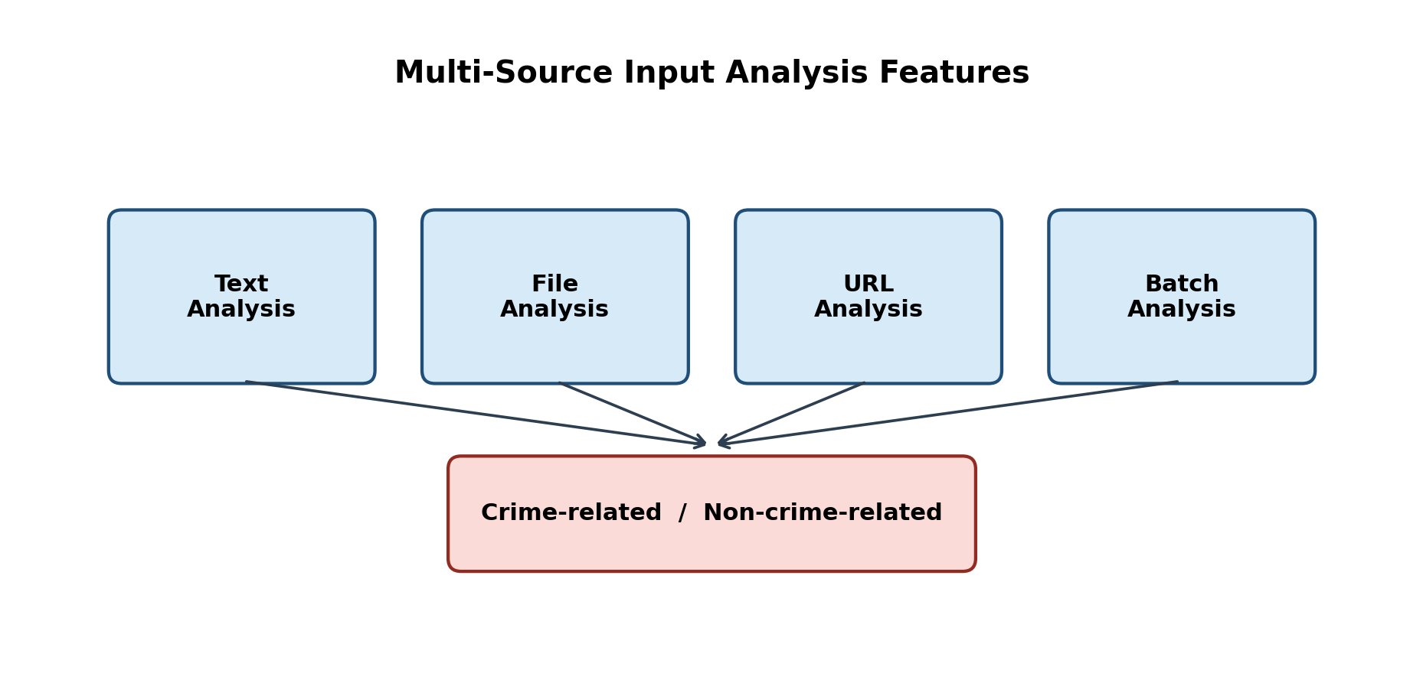
Figure 3.0: Multi-Source Input Analysis Features Leading to Binary Classification

3.3 System Features

3.3.1 Authentication and Authorization
BAREAI implements secure registration and login with JSON Web Tokens (JWT). Email OTP verification strengthens account security. Investigators may be created by administrators with forced password change on first login. Roles restrict access to dashboards, case tools, blacklist management, and audit logs.

3.3.2 Automated Crime Text Classification
The core feature accepts Somali (and mixed) text reports and returns a binary prediction (crime-related / not crime-related), confidence score, optional matched keywords, and extracted location mentions. Classification is performed by the Flask NLP service and may be reinforced by Somali crime-keyword heuristics to reduce false negatives for high-risk phrases.

3.3.3 Multi-Source Input Analysis
Users can analyse: (a) pasted text; (b) webpage URLs extracted with HTML parsing; (c) uploaded documents (PDF, DOCX, TXT); and (d) batch submissions. Guest users are limited to a small number of free analyses to protect computational resources.

3.3.4 Blacklist Monitoring
Administrators and investigators maintain a watchlist of Facebook pages, websites, keywords, and persons. Facebook pages can be scanned periodically using automated browser scraping. Website pages can be scanned on demand. Detected crime content generates alerts and investigation cases.

3.3.5 Case Management and Notifications
When crime-related content is confirmed, the system creates a pending investigation case and notifies available investigators. The first investigator to accept the case claims ownership. Investigators can update status, write findings, submit formal reports, and flag false or malicious reports for administrative review.

3.3.6 Dashboard, Reports, and Audit Logging
The admin dashboard summarises analyses, detected crimes, users, investigators, blacklist items, and active cases. Operational reports and activity logs support accountability and organisational oversight.

3.4 System Architecture
The BAREAI architecture is expressed as an end-to-end pipeline rather than a narrow application-to-model link. Social media and related digital text enter the system through collection interfaces (text, file, URL, batch, and monitors). Collected text is preprocessed, converted into TF-IDF features, and classified by the machine learning model into crime-related or non-crime-related labels. Results are returned to the web application for display, history storage, and optional case dispatch.
Figure 3.1 presents this pipeline from social media data to the web application. The flow emphasises that NLP inference is only one stage inside a complete operational system that also includes authentication, monitoring, and investigation support.

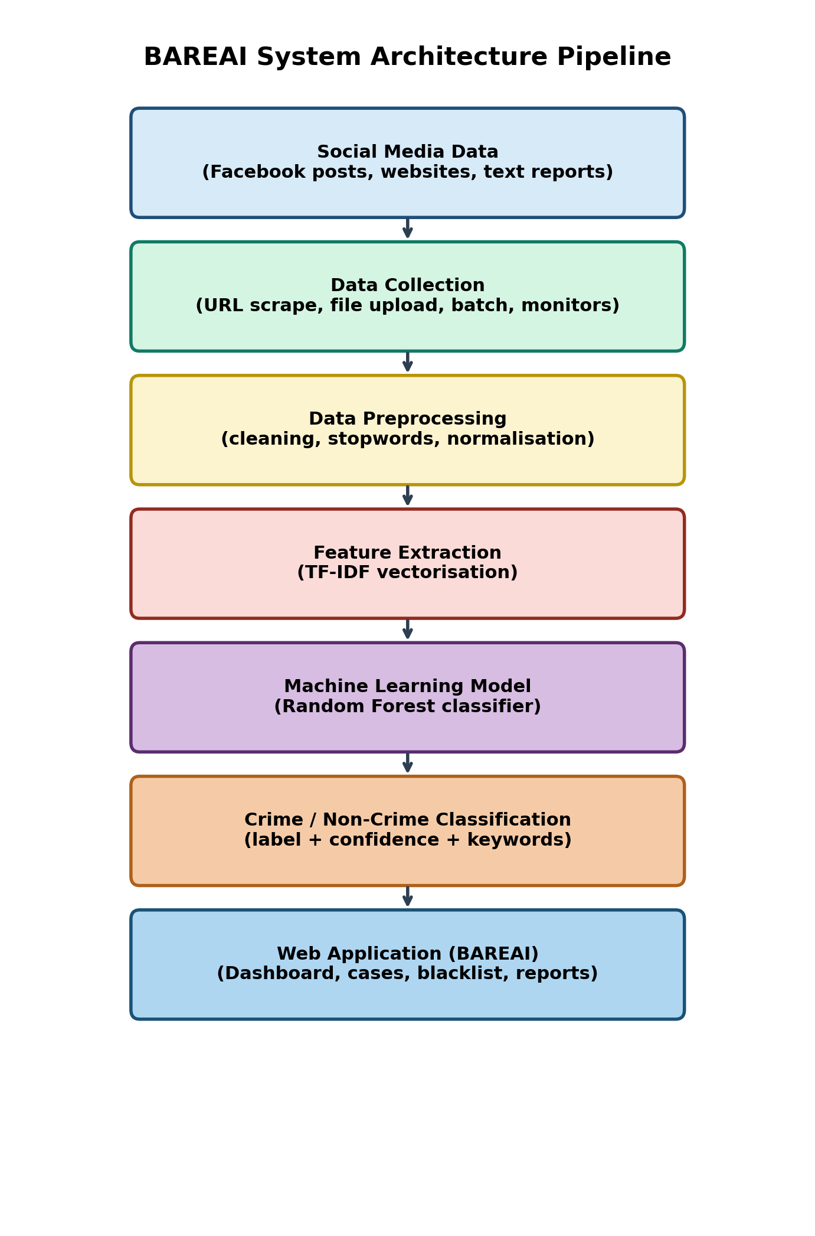
Figure 3.1: BAREAI System Architecture Pipeline (Social Media Data to Web Application)

3.5 Data Acquisition and Preprocessing

3.5.1 Dataset Source
The experimental dataset contains 9,999 labelled text samples stored in CSV format. Each record includes a source URL, the raw text body, and a binary category label: crime-related or not crime-related. The corpus is nearly balanced (5,000 crime-related and 4,999 not crime-related). Sources are predominantly Somali-language news and social-media style texts (for example BBC Somali and related outlets), manually labelled for supervised learning.
Table 3.1: Dataset Column Description and Summary Statistics
Attribute | Description
url | Source link of the collected text
text | Raw report / article / post content
category | Binary label: crime-related or not crime-related
Total samples | 9,999
Crime-related | 5,000 (50.01%)
Not crime-related | 4,999 (49.99%)
Average length | Approximately 1,787 characters / 277 words

3.5.2 Data Preprocessing Steps
Preprocessing was implemented in a Jupyter notebook prior to model training. The pipeline removes incomplete rows, normalises casing, strips URLs and emails, retains Latin and Arabic script characters relevant to Somali orthography, collapses excess whitespace, tokenises by whitespace, and removes Somali stopwords (approximately 284 stopwords when an external stopword list is available; otherwise a built-in fallback list is used).

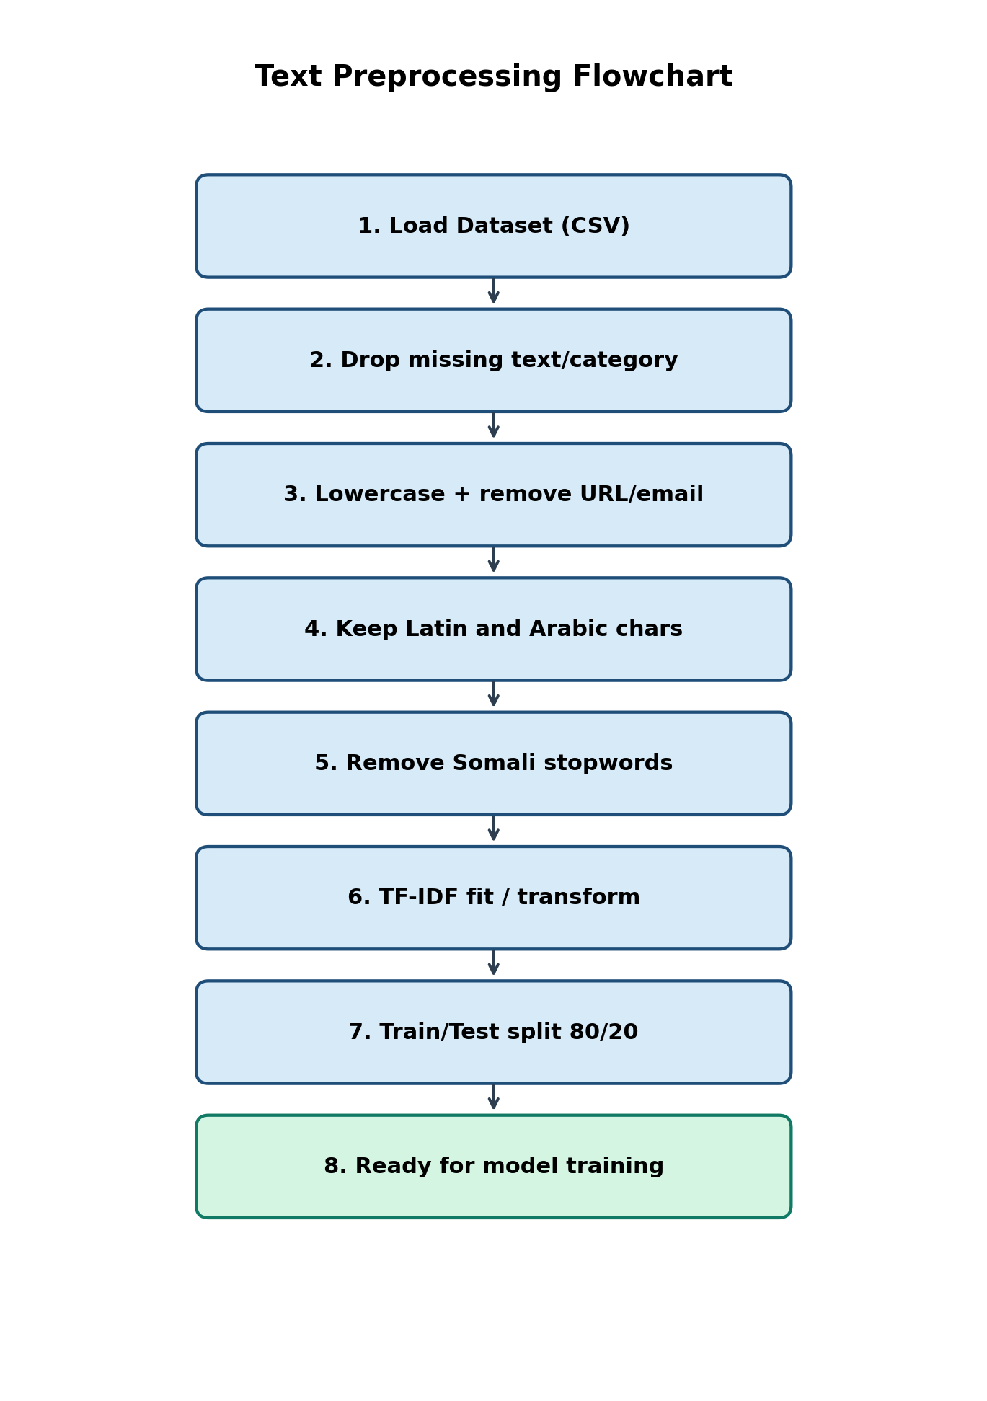
Figure 3.2: Text Preprocessing Flowchart

3.6 Feature Engineering / Representation
Text was transformed into numerical features using Term Frequency–Inverse Document Frequency (TF-IDF). During experimentation, TF-IDF and Bag-of-Words representations were compared with constrained vocabulary settings. For the notebook experiments, TF-IDF used max_features=300, min_df=2, max_df=0.95, and ngram_range=(1,2). The deployed production vectorizer uses a larger vocabulary (max_features=5000) to improve coverage during live inference.
The dataset was split into training (80%) and testing (20%) subsets using stratified sampling with random_state=42, yielding 7,999 training samples and 2,000 test samples (1,000 per class in the test set). Stratification preserved class balance and enabled fair comparison across classifiers.
Table 3.2: Feature Engineering and Split Configuration
Item | Configuration
Feature method | TF-IDF (primary); Bag-of-Words (experimental)
Notebook TF-IDF | max_features=300, ngram_range=(1,2)
Deployed TF-IDF | max_features=5000, unigrams
Train/Test split | 80% / 20%, stratified
Random state | 42
Target classes | crime-related, not crime-related

3.7 Model / Algorithm Development

3.7.1 Baseline Model and Model Selection
Multiple supervised classifiers were trained as baselines and candidates for deployment: Random Forest, Gradient Boosting, Linear Support Vector Machine (SVM), Logistic Regression, Decision Tree, Multinomial Naive Bayes, and K-Nearest Neighbours (K-NN). An MLP neural network configuration was also attempted but did not complete successfully in the experimental notebook run. Although the literature review discussed transformer models such as BERT as future-capable approaches, the implemented FYP focused on classical NLP pipelines that are lightweight, interpretable, and deployable on limited university hardware.
Random Forest was selected as the best-performing model based on Accuracy, Precision, Recall, and F1-score on the held-out test set. The selected forest used 100 estimators. The trained model and vectorizer were serialised with Joblib (crime_model.pkl and vectorizer.pkl) for production use.

3.7.2 Model Evaluation
Classification performance was measured using Accuracy, Precision, Recall, and F1-score. Complementary visualisations include a confusion matrix and comparative bar charts. Hyperparameters were controlled through consistent random seeds and shared train/test splits so that differences reflect model behaviour rather than sampling noise.
Table 3.3: Model Evaluation Results on the Test Set
Model | Accuracy | Precision | Recall | F1-Score
Random Forest | 0.8955 | 0.8955 | 0.8955 | 0.8955
Gradient Boosting | 0.8840 | 0.8858 | 0.8840 | 0.8839
Linear SVM | 0.8635 | 0.8636 | 0.8635 | 0.8635
Logistic Regression | 0.8580 | 0.8583 | 0.8580 | 0.8580
Decision Tree | 0.8475 | 0.8475 | 0.8475 | 0.8475
Naive Bayes | 0.8305 | 0.8316 | 0.8305 | 0.8304
K-NN | 0.7830 | 0.8251 | 0.7830 | 0.7757

3.7.3 Model Deployment Framework
The selected Random Forest model is served through a Flask REST API that exposes health checks and a /predict endpoint. The Express backend proxies classification requests to the Flask service, enriches responses with blacklist matches, and stores outcomes in MongoDB. This separation allows the NLP model to be updated independently of the web interface.

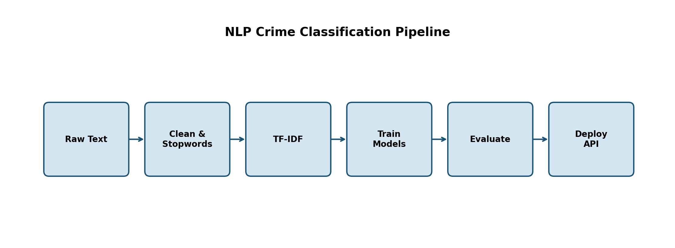
Figure 3.3: NLP Crime Classification Pipeline

3.8 Requirements

3.8.1 System Requirements

Hardware Requirements
The hardware requirements define the minimum physical resources needed to develop, train, and run the application efficiently.
Table 3.4: Hardware Requirements
Component | Minimum Specification
Processor | Intel Core i5 (or equivalent) and above
Memory (RAM) | 8 GB minimum; 16 GB recommended for training
Storage | 20 GB free disk space
Display | 1366 × 768 or higher
Network | Stable internet connection for APIs and scraping

Software Requirements
Table 3.5: Software Requirements
Category | Tools / Technologies
Operating Systems | Windows 10/11, Linux, or macOS
IDE / Editors | Visual Studio Code, Jupyter Notebook
Programming Languages | JavaScript (Node.js), Python 3.x
Frontend | React 19, Vite, Tailwind CSS, Axios, Recharts
Backend | Express 5, Mongoose, JWT, Multer, Puppeteer, Cheerio
ML / NLP | scikit-learn, pandas, numpy, joblib, Flask
Database | MongoDB
Version Control | Git

3.8.2 User Requirements

3.8.2.1 Functional Requirements
FR1: The system shall allow users to submit text for crime classification.
FR2: The system shall accept URL and file inputs and extract readable text.
FR3: The system shall return prediction label and confidence score.
FR4: The system shall authenticate users and enforce role-based access.
FR5: The system shall create investigation cases for crime detections.
FR6: The system shall allow investigators to claim and update cases.
FR7: The system shall support blacklist CRUD and monitoring scans.
FR8: The system shall notify relevant users when crimes are detected.
FR9: The system shall provide an admin dashboard and audit logs.
FR10: The system shall allow flagging of false or malicious reports.

3.8.2.2 Non-Functional Requirements
NFR1 (Performance): Classification responses should return within a few seconds under normal load.
NFR2 (Usability): Interfaces should be clear for non-technical investigators.
NFR3 (Reliability): Analysis history and case records must be persisted durably.
NFR4 (Security): Passwords are hashed; API routes are JWT-protected where required.
NFR5 (Scalability): Services are modular so model and API can scale separately.
NFR6 (Maintainability): Code is organised by controllers, models, routes, and services.
NFR7 (Portability): The stack runs on common desktop operating systems.

3.9 Feasibility Study

3.9.1 Technical Feasibility
The project is technically feasible because all required tools are open-source and widely documented. React, Express, Flask, scikit-learn, and MongoDB are mature technologies already familiar to Computer Applications students. Model training on approximately 10,000 text samples is computationally practical on a standard laptop.

3.9.2 Economic Feasibility
Development relied on free software stacks and publicly available dataset construction effort. No commercial NLP API subscription is required for the core classifier, which makes the solution economically suitable for low-resource institutional settings.

3.9.3 Operational Feasibility
Operationally, BAREAI maps directly onto existing investigative workflows: intake, triage, assignment, and reporting. Role-based screens reduce training overhead for admins and investigators.

3.9.4 Schedule Feasibility
The work was organised into literature review, data preparation, model experimentation, backend/frontend development, integration testing, and thesis writing—aligned with the standard FYP academic calendar.

3.10 System Design
System design artefacts include a use-case view of actors and major interactions, and a logical database schema describing MongoDB collections and relationships. Detailed implementation screenshots and runtime results are presented in Chapter IV.

3.10.1 Use Case Diagram
The primary actors are Admin, Investigator, Public User, and the AI Service. Major use cases include classify text report, manage blacklist, claim/investigate case, view dashboard, manage users, flag false reports, and public analysis.

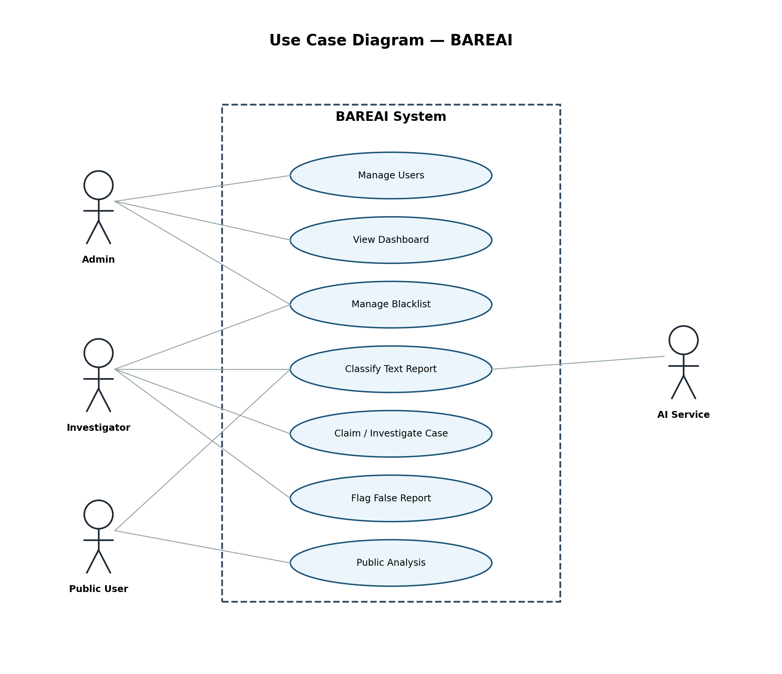
Figure 3.4: Use Case Diagram of BAREAI

3.10.2 Database Design
MongoDB collections were designed around operational entities. User stores identity and role fields. History stores each analysis event. InvestigationCase links one-to-one with a crime History record and tracks assignment status. BlacklistItem defines monitored sources. Notification and ActivityLog support communication and auditing. InvestigationReport stores investigator findings. Relationships are enforced logically through foreign-key style ObjectId references.

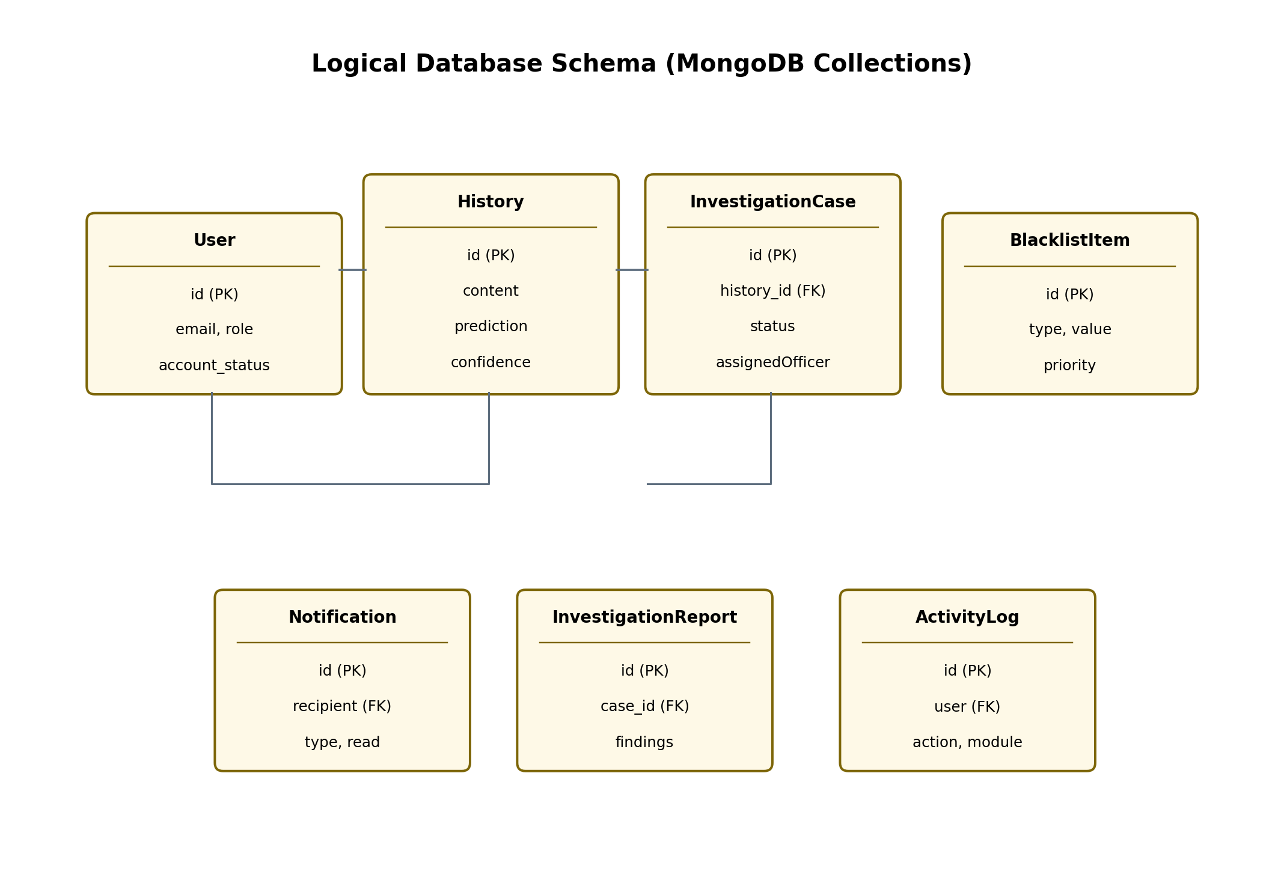
Figure 3.5: Logical Database Schema of BAREAI
Table 3.6: Database Collections Summary
Collection | Key Fields | Purpose
User | email, role, account_status | Authentication and RBAC
History | content, prediction, confidence | Analysis archive
InvestigationCase | history, status, assignedOfficer | Case workflow
InvestigationReport | case, findings, status | Formal reports
BlacklistItem | type, value, priority | Watchlist monitoring
Notification | recipient, type, read | In-app alerts
ActivityLog | action, module, user | Audit trail

Methodologically, reproducibility was maintained by fixing random seeds, documenting preprocessing steps, and serialising both the vectorizer and the classifier. This ensures that the same pipeline used in training can be reconstructed at inference time inside the Flask service. Hyperparameter choices for Random Forest favoured stable generalisation over aggressive depth that could overfit sparse TF-IDF space.
The feasibility study confirmed that open-source tools were sufficient for the project timeframe. Economic feasibility is supported by the absence of paid NLP APIs for core classification. Operational feasibility is supported by interfaces that mirror investigator tasks: analyse, claim, update, and report. Schedule feasibility followed the standard FYP calendar from literature review through demonstration and thesis writing.
System design artefacts—including use cases and database collections—were kept aligned with implemented code. Where UML-level detail is required for examination, figures in this chapter and the appendices provide the necessary references. The architecture pipeline diagram deliberately starts from social media data and ends at the web application to satisfy the requirement that design show the full flow, not only model inference.
Data acquisition emphasised near-balanced classes so that accuracy would not be inflated by a majority non-crime class. Stratified splitting preserved that balance in training and testing. Preprocessing removed URLs and emails, retained scripts relevant to Somali orthography, and removed stopwords to focus the vectorizer on content-bearing tokens.
Feature engineering experiments compared Bag-of-Words and TF-IDF settings. TF-IDF was retained because it down-weights overly common tokens and improves separation in sparse spaces. The deployed vectorizer uses a larger vocabulary than early notebook experiments to improve coverage during live inference on unseen posts.
Model development compared Logistic Regression, SVM, Random Forest, and additional baselines. Random Forest delivered the strongest overall metrics and was selected. Deployment through Flask keeps inference language-aligned with training (Python and scikit-learn) while the Express backend orchestrates authentication and persistence for the React clients.
Hardware and software requirements were selected to match typical student laptops used at JUST. This decision supports reproducibility during viva demonstration without specialised servers.
Functional requirements were written as testable statements (FR1–FR10), while non-functional requirements captured performance, security, and maintainability expectations. This structure follows the AI FYP guideline for methodology chapters.
Database design used MongoDB collections that map cleanly to operational entities. The one-to-one link between crime History records and InvestigationCase documents reduces ambiguity when officers claim work items.

CHAPTER FOUR: IMPLEMENTATION AND RESULTS

4.1 Dataset Description
The dataset used for training and evaluation consists of 9,999 Somali-oriented text entries organised as rows with URL, text, and category attributes. Labels are binary and nearly balanced, which reduces the need for aggressive resampling. Examples include news-style narratives and social posts discussing incidents that may or may not constitute criminal activity. Average document length is about 277 words, with substantial variance, reflecting real-world textual heterogeneity.

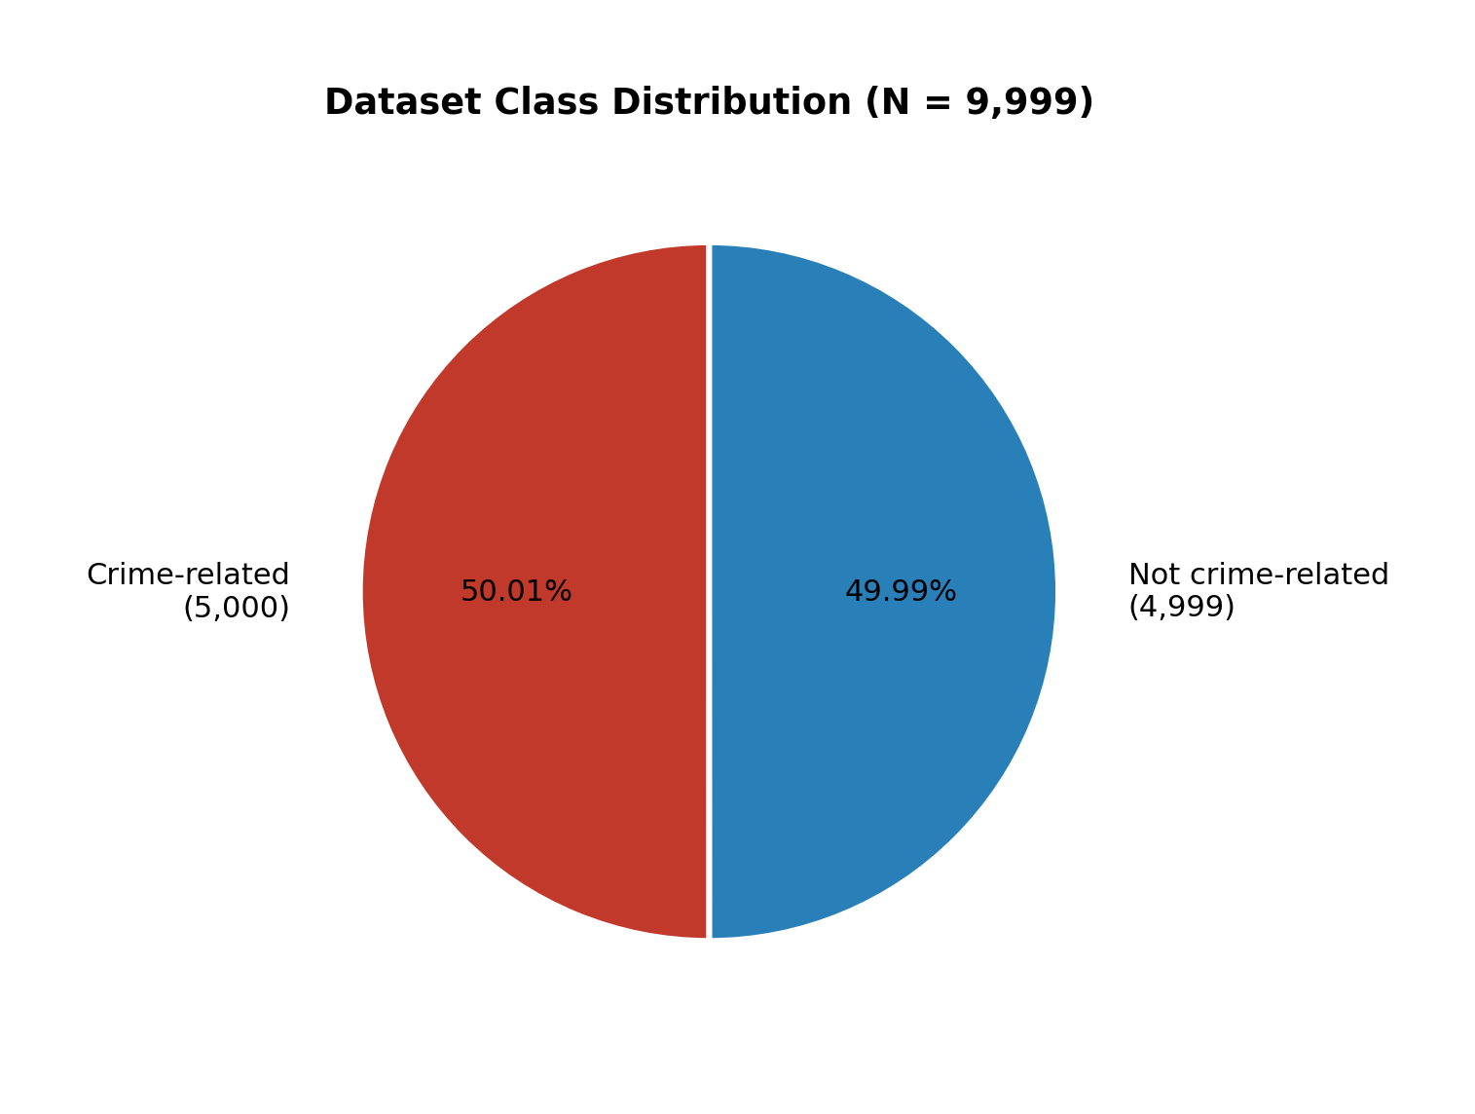
Figure 4.1: Dataset Class Distribution (N = 9,999)

4.2 ML Pipeline Implementation
The machine learning pipeline was developed through a structured process that included data loading, cleaning, stopword removal, TF-IDF vectorisation, stratified splitting, multi-model training, metric comparison, model selection, serialisation, and API deployment. Training and testing were performed on disjoint subsets to assess generalisation. The final Random Forest classifier was validated on the 2,000-sample test set and then packaged for Flask inference.
At runtime, the Flask service transforms incoming text with the saved TF-IDF vectorizer, obtains class probabilities from Random Forest, and applies Somali crime-keyword overrides when explicit high-risk terms are present. Location mentions are extracted with pattern matching against known Somali place names. The Express layer stores the enriched response and triggers case creation when isCrime is true.

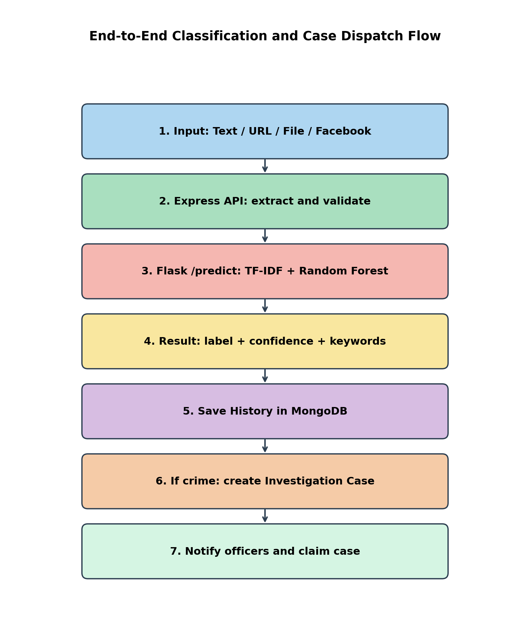
Figure 4.2: End-to-End Classification and Case Dispatch Flow


Figure 4.3: ML Pipeline Implementation Stages

4.3 System Design and Deployment

4.3.1 Backend Implementation
The backend is implemented in Node.js using Express. Key route groups include /api/auth, /api/analysis, /api/investigation, /api/blacklist, /api/dashboard, /api/notifications, /api/reports, /api/users, and /api/audit-logs. Controllers coordinate validation, AI inference calls, MongoDB persistence, and notification dispatch. Background Facebook monitoring uses Puppeteer; website scanning uses Cheerio with SSRF-safe fetching.

4.3.2 Frontend Implementation
The frontend is a React SPA with role-aware routing. Public users access landing and analysis pages. Investigators focus on cases, blacklist tools, and reports. Admins access the dashboard, user management, and audit logs. Charts are rendered with Recharts, and PDF exports are supported where reporting is required.

4.3.3 AI Service Integration
The Flask service listens on port 5001 by default and exposes /health and /predict. The Express backend communicates with AI_MODEL_URL, keeping the browser isolated from direct model access. This improves security and allows independent redeployment of the classifier.

4.3.4 Deployment Topology
In the local development and demonstration environment, the frontend runs on port 5173, the Express API on port 5000, and the Flask model service on port 5001, with MongoDB as the shared database. The same topology can be migrated to a cloud host by containerising each service.

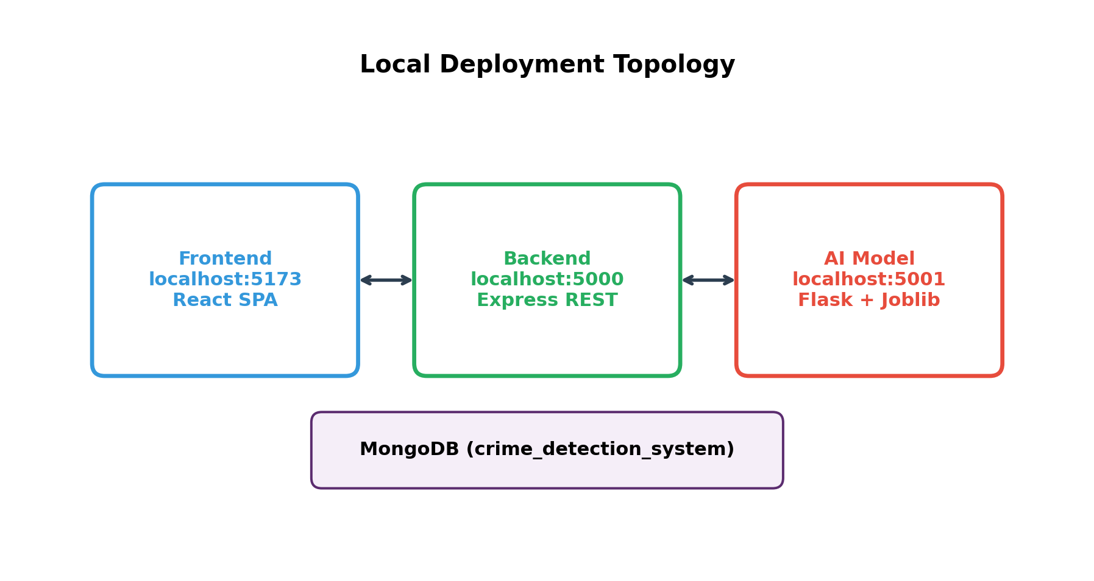
Figure 4.4: Local Deployment Topology of BAREAI Services

4.3.5 Implemented User Interface Modules
The following interface modules were implemented and tested during system integration:
Table 4.1: Implemented Interface Modules
Module | Primary Users | Description
Landing / Public Analysis | Public users | Submit text/URL/file for classification
Admin Dashboard | Admin | Operational KPIs and trends
User Management | Admin | Create and manage accounts/roles
Case Management | Admin, Investigator | Claim, update, and close cases
Blacklist / Monitoring | Admin, Investigator | Watch Facebook/websites/keywords
Reports & Audit Logs | Admin, Investigator | Accountability and analytics
Profile & Settings | All authenticated | Account and preference management

Representative interface screens of the implemented website are presented below. Each screen demonstrates how users interact with Text, File, URL, and Batch analysis features and how outputs are shown as crime-related or non-crime-related.

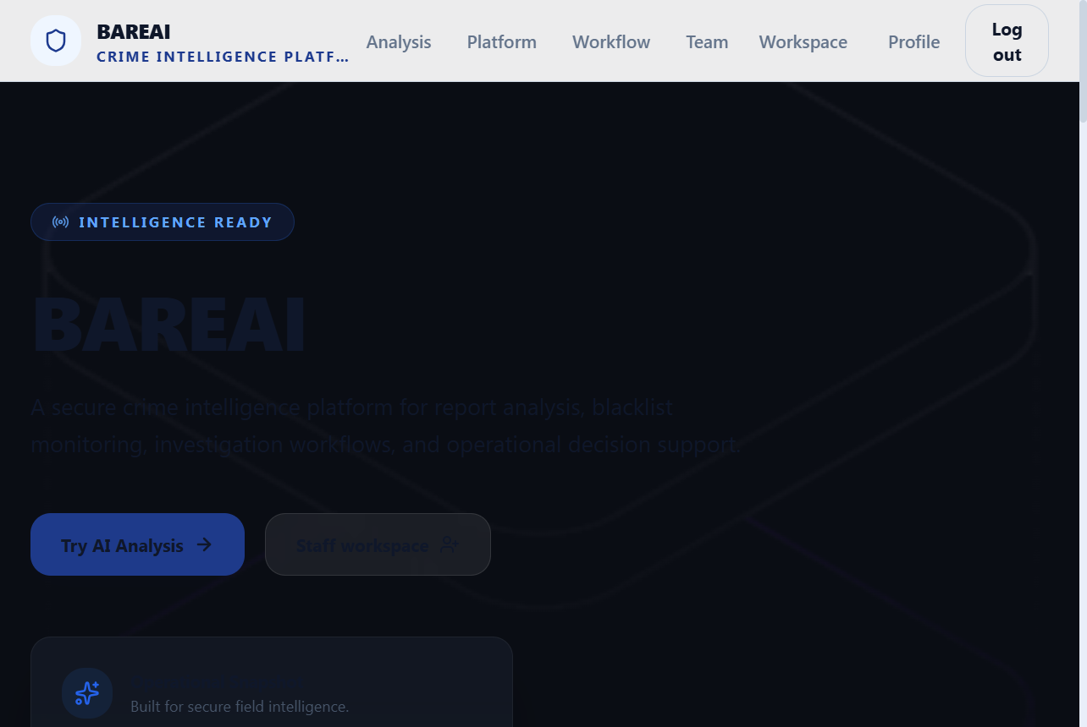
Figure 4.5: BAREAI Landing / Home Page

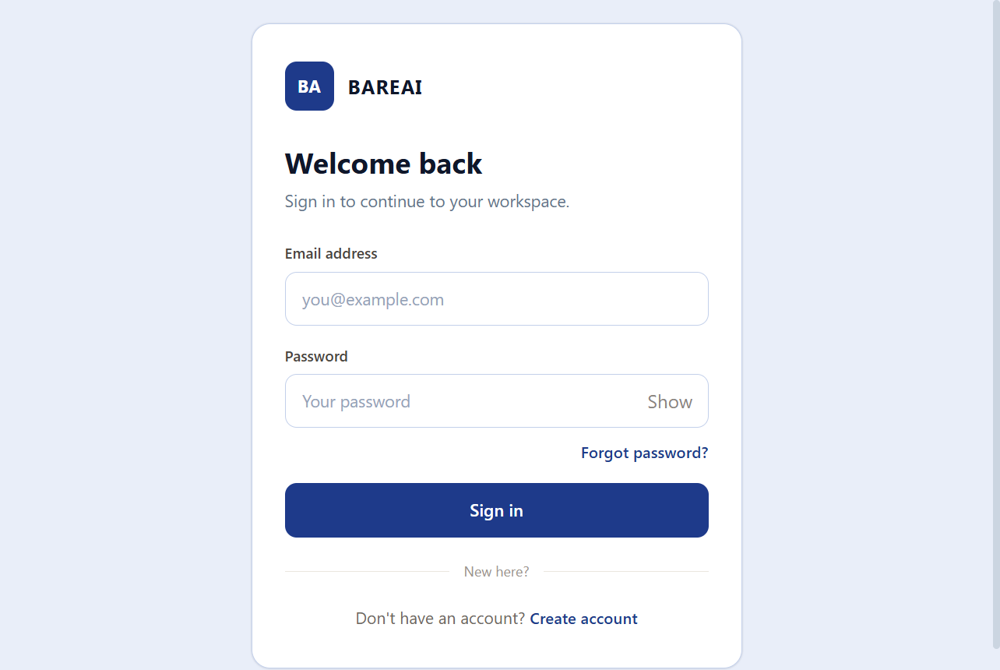
Figure 4.6: BAREAI Login Page

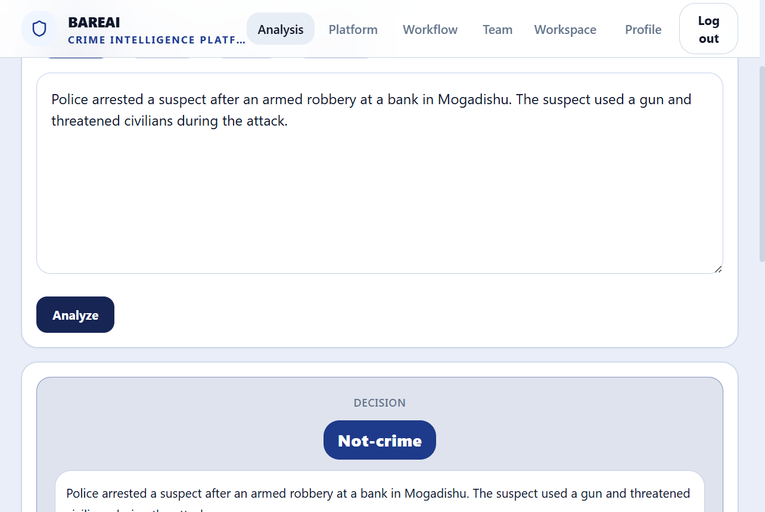
Figure 4.7: Text Analysis Page with Crime / Non-Crime Result

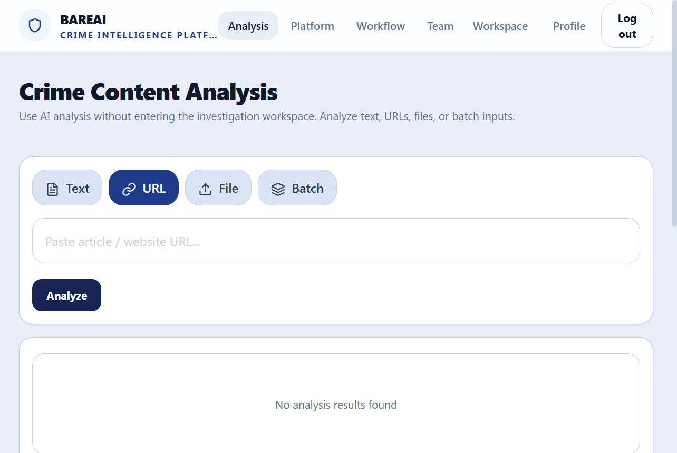
Figure 4.8: URL Analysis Page

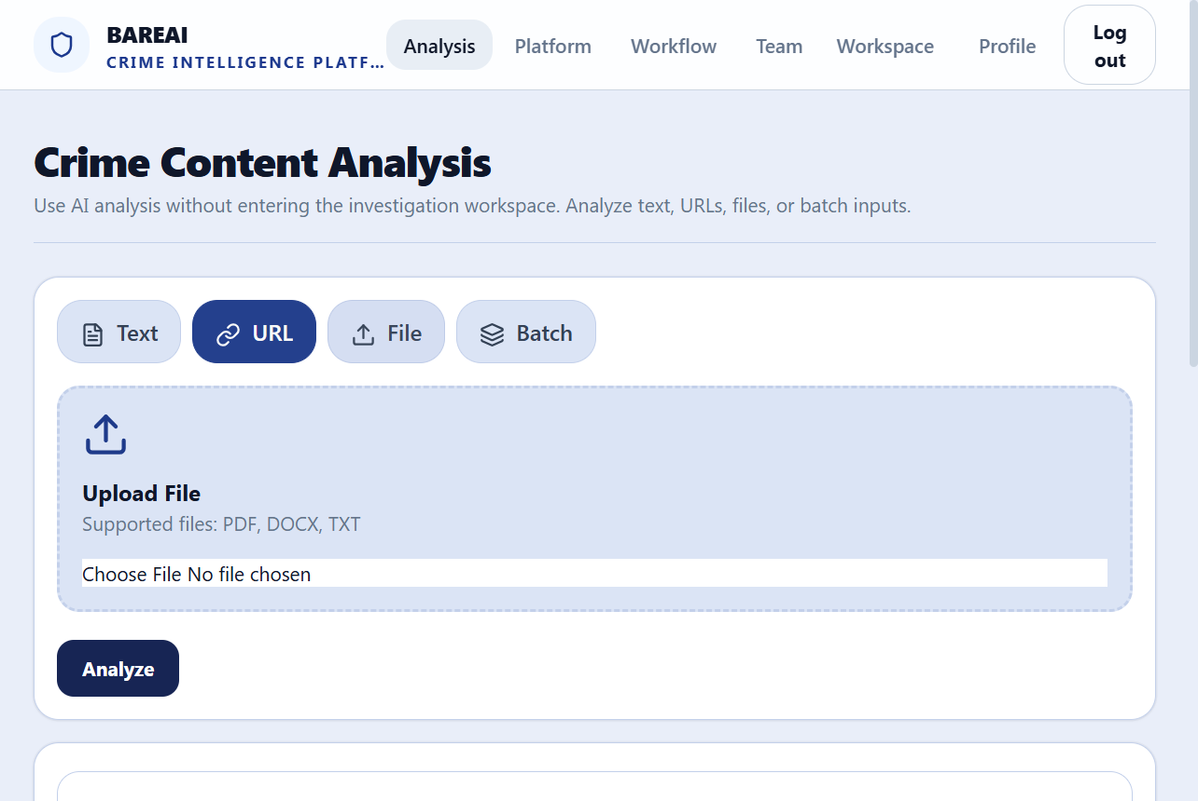
Figure 4.9: File Analysis Page

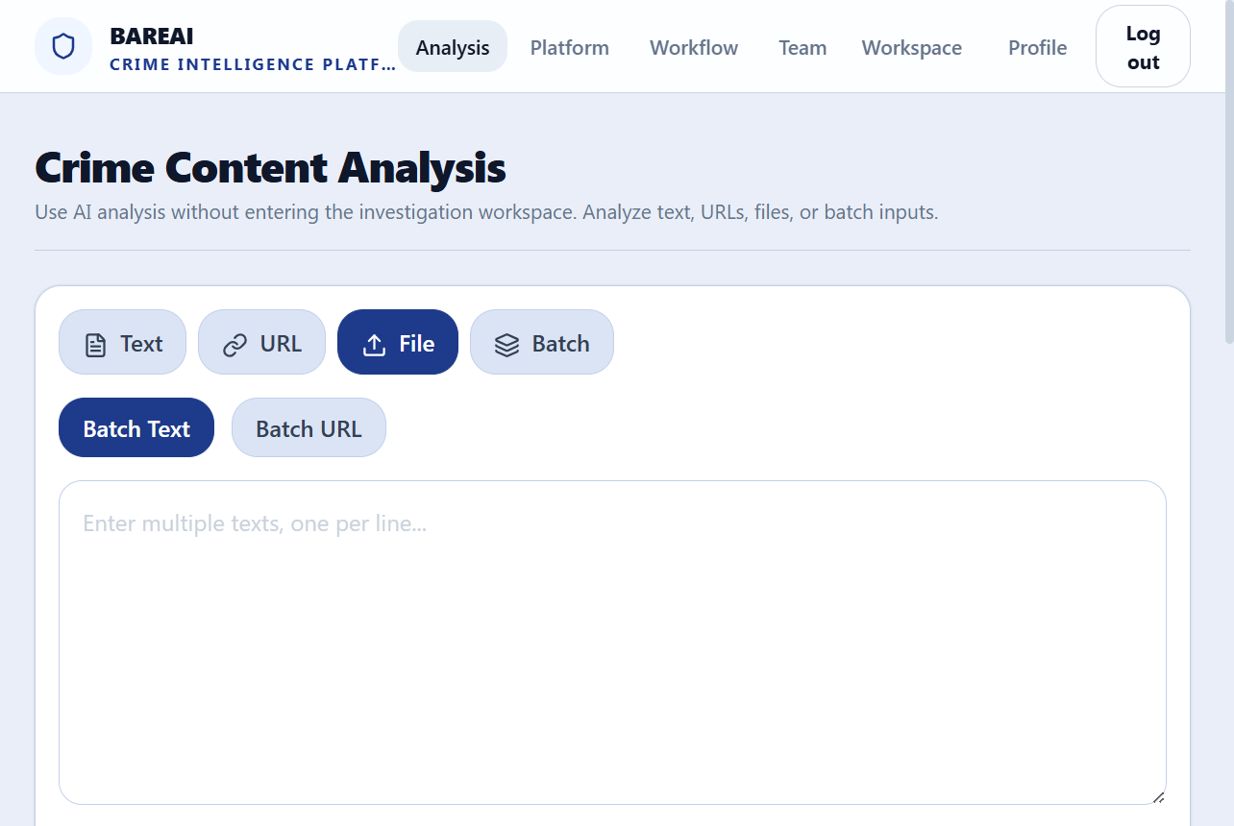
Figure 4.10: Batch Analysis Page

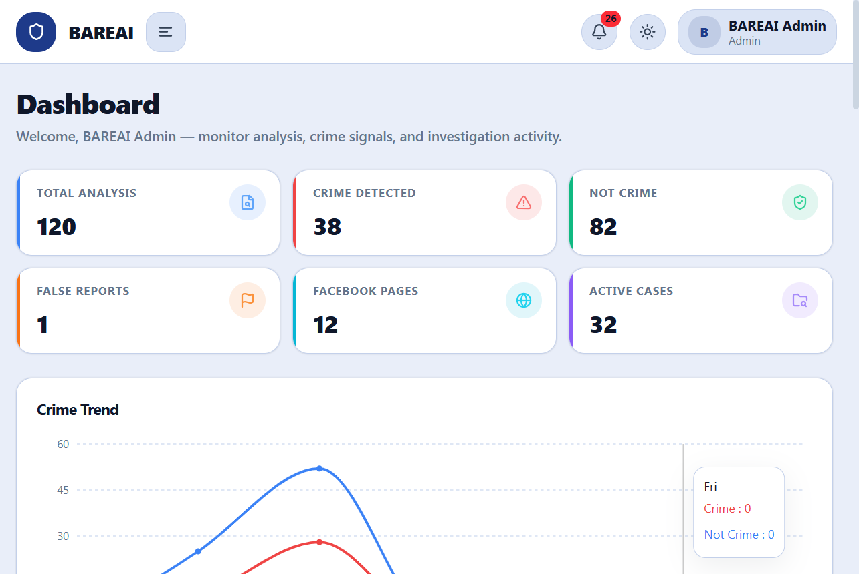
Figure 4.11: Administrator Dashboard

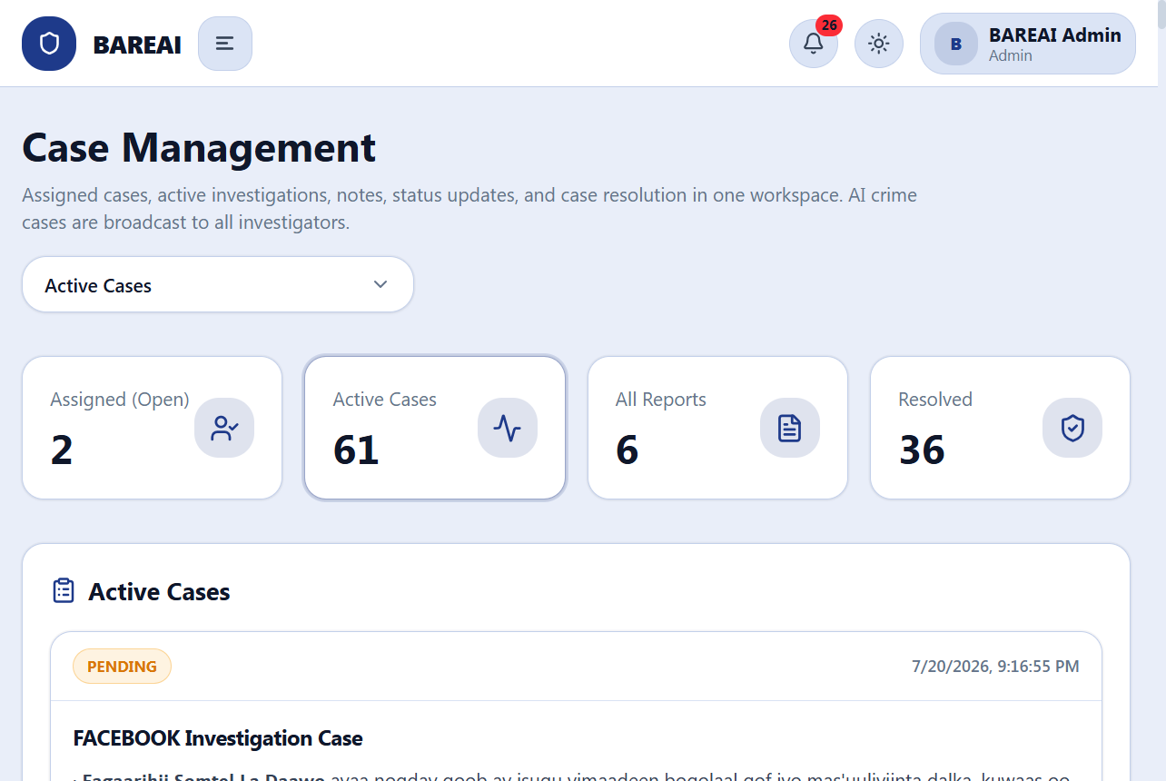
Figure 4.12: Investigation Case Management Page

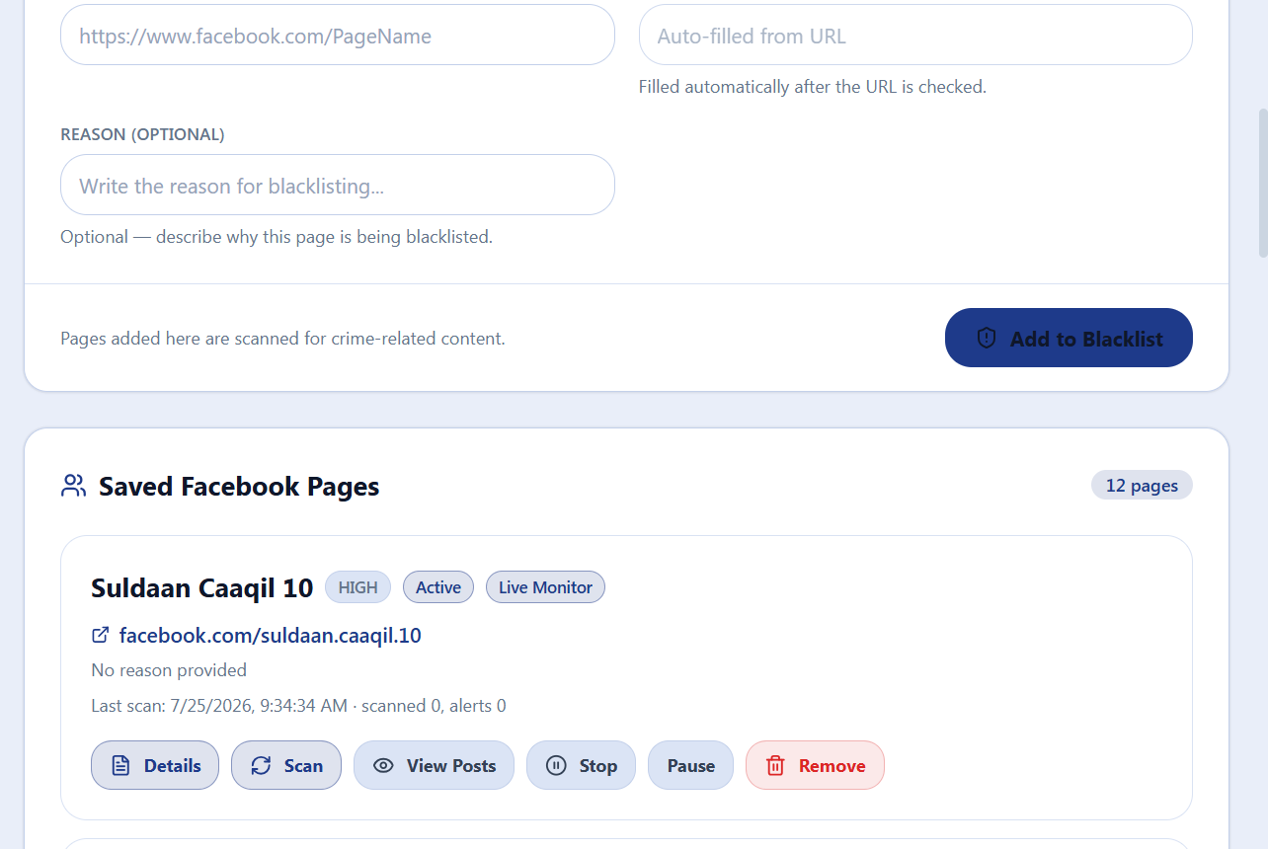
Figure 4.13: Blacklist and Monitoring Page

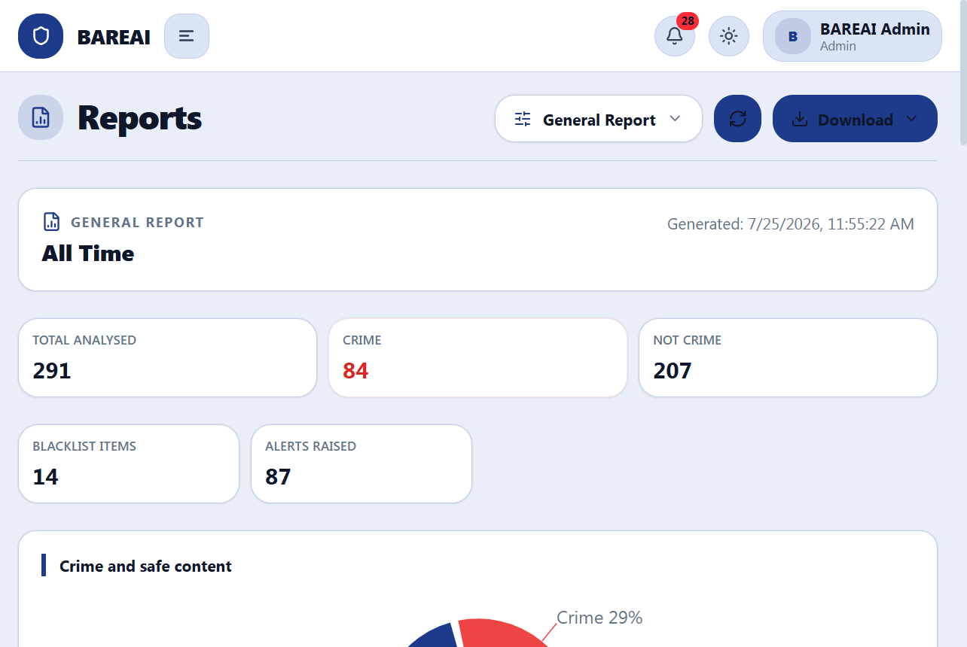
Figure 4.14: Notifications and Reports Page

4.4 Website Interface Screenshots — Feature Walkthrough
The landing page introduces BAREAI as an intelligence platform for automatic classification of social media posts. It states clearly that the system separates content into crime-related and non-crime-related classes and highlights Text, File, URL, and Batch analysis entry points. The login page authenticates Admin, Investigator, and Public User roles before granting access to protected modules.
On the Text Analysis page, a user pastes a social media post; the system returns the predicted class and confidence. URL Analysis fetches webpage text before classification. File Analysis accepts PDF/DOCX/TXT uploads. Batch Analysis lists several posts and labels each one independently. These four features together cover the most common ways crime-related narratives appear online.
Administrative screens support operations after classification. The dashboard summarises analyses and detections; the case board allows investigators to claim crime-related items; blacklist monitoring watches high-risk Facebook pages and websites; and notifications/reports keep the organisation informed. Together, these screens show that BAREAI is not only a model demo but a complete workflow application.

4.5 Data Visualization (Results Presentation)
Experimental results are summarised using comparative charts, a confusion matrix, and metric bars for the best model. Random Forest achieved 89.55% across Accuracy, Precision, Recall, and F1-score on the test set. Approximate confusion-matrix cell counts for a balanced 2,000-sample test partition are shown to illustrate error distribution under near-symmetric performance.

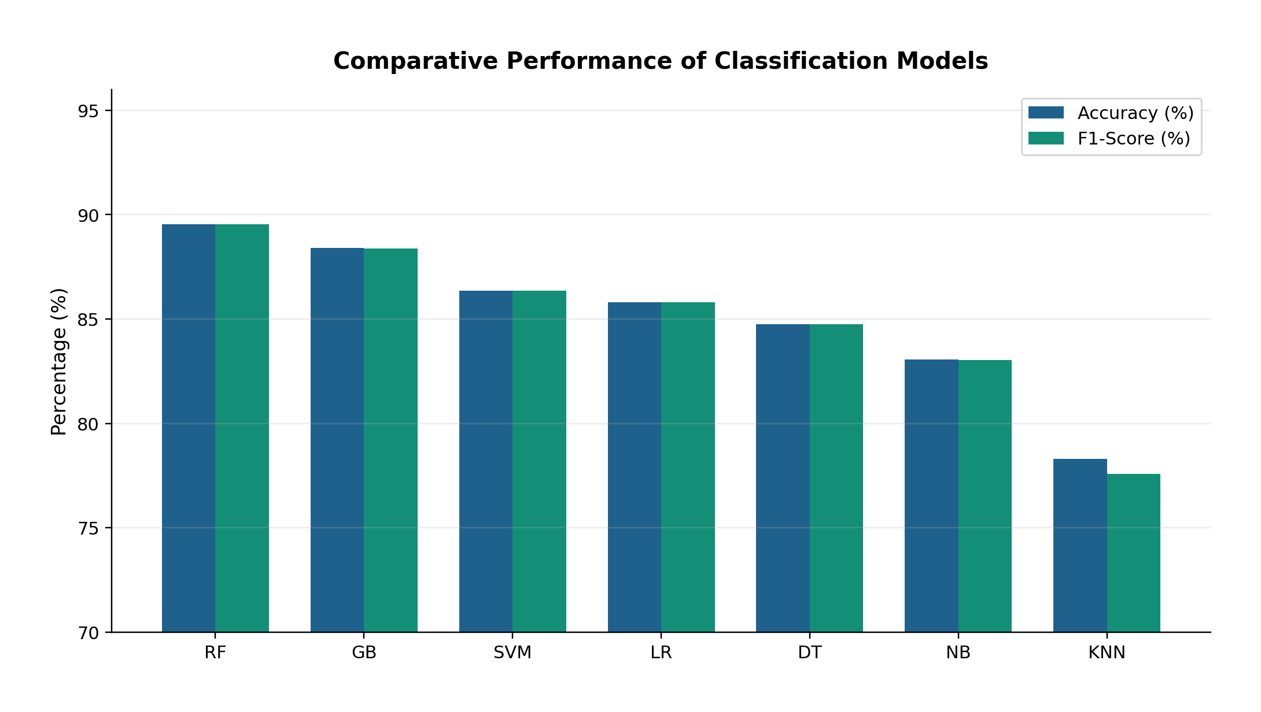
Figure 4.15: Comparative Performance of Classification Models

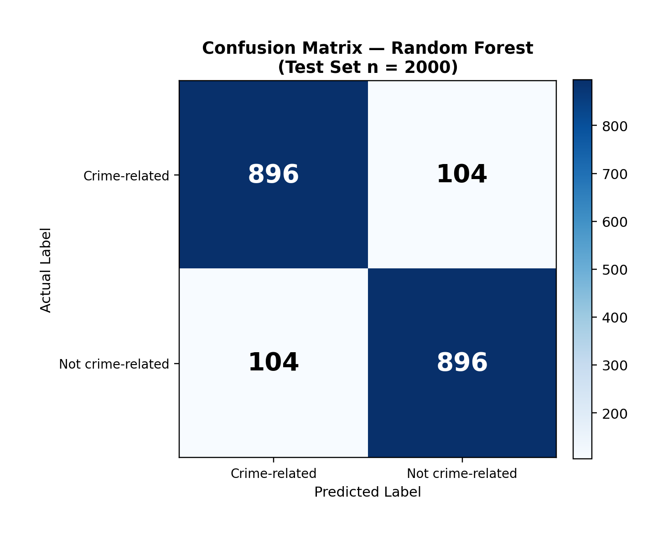
Figure 4.16: Confusion Matrix of the Random Forest Classifier

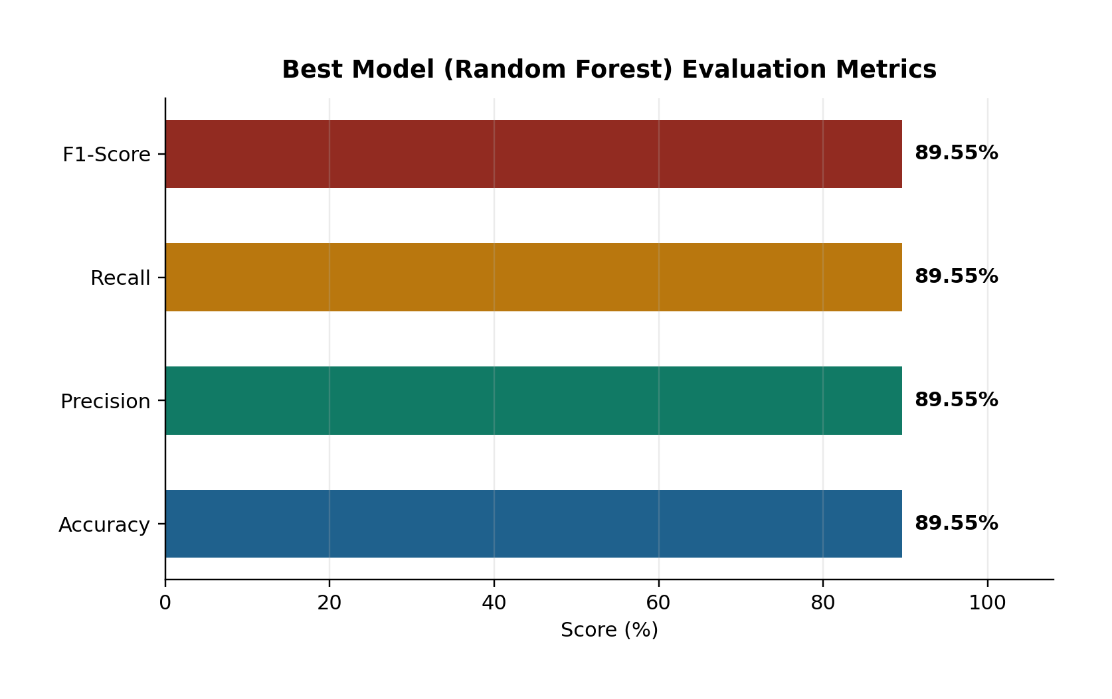
Figure 4.17: Evaluation Metrics of the Selected Random Forest Model

4.6 Model Comparison
Table 4.2 consolidates the comparative evaluation. Random Forest outperformed all baselines, exceeding Gradient Boosting by about 1.15 percentage points in accuracy and outperforming Linear SVM by about 3.20 percentage points. Tree ensembles were particularly effective for TF-IDF features of Somali crime text, while K-NN lagged due to high-dimensional sparse representations.
Table 4.2: Ranked Model Comparison Summary
Rank | Model | Accuracy (%) | F1-Score (%) | Remark
1 | Random Forest | 89.55 | 89.55 | Selected for deployment
2 | Gradient Boosting | 88.40 | 88.39 | Strong runner-up
3 | Linear SVM | 86.35 | 86.35 | Competitive linear baseline
4 | Logistic Regression | 85.80 | 85.80 | Fast interpretable baseline
5 | Decision Tree | 84.75 | 84.75 | Weaker generalisation
6 | Naive Bayes | 83.05 | 83.04 | Strong speed, lower score
7 | K-NN | 78.30 | 77.57 | Least suitable

Beyond offline metrics, system-level testing confirmed that the deployed hybrid pipeline (Random Forest + TF-IDF + keyword enrichment) successfully classifies live inputs and integrates with case management. This demonstrates that the research objectives—reducing manual triage, preprocessing crime text, extracting features, and delivering an automated NLP system—were achieved in a working prototype.
Implementation testing covered API responses, model health checks, and end-to-end user journeys for Text, File, URL, and Batch analysis. In each journey, the expected outputs were a binary class label and a confidence value. When crime-related content was detected, the system created investigation cases and emitted notifications, confirming integration between the NLP service and business logic.
Website screenshots document the visual state of the prototype at demonstration time. They show that public users can analyse posts without administrative privileges, while investigators and admins access operational modules. This separation of concerns is essential for security and usability in a multi-role environment.
Comparative tables confirm that Random Forest was the strongest model among those evaluated, including Logistic Regression and SVM. Accuracy near 89.55% is treated as the primary reported headline metric because it matched precision, recall, and F1 on the balanced test partition. Future work may push beyond this ceiling with larger datasets or contextual embeddings, but the deployed system already meets the FYP objective of automating crime versus non-crime triage.
Additional functional tests verified guest rate limits, JWT-protected routes, and blacklist matching. These tests ensure that classification is not the only quality gate; operational controls also protect the platform from abuse and help investigators focus on monitored sources.
Performance observations during local demonstration indicated that inference responses typically returned within a few seconds for short to medium posts, which is acceptable for interactive triage. Batch jobs naturally take longer in proportion to the number of items submitted, which users can anticipate from the interface design.
Overall, Chapter Four provides empirical and visual evidence that BAREAI was implemented as specified: social media text is collected through multiple channels, classified into crime-related or non-crime-related outputs, and managed through dashboard, case, and monitoring screens.
During integration testing, model downtime was simulated by stopping the Flask service. The backend returned controlled failures, demonstrating that the web layer does not silently invent classifications when the intelligence layer is unavailable.
Screenshot evidence was prepared for every major page so examiners can verify that Text, File, URL, and Batch analysis are not merely proposed but implemented.
Model comparison discussion emphasises that Logistic Regression and SVM remain useful baselines, yet Random Forest provided the best overall balance for the deployed artefact at approximately 89.55 percent accuracy.

4.7 Detailed Testing Scenarios
To strengthen validation evidence, structured testing scenarios were executed across the four analysis features. Each scenario records the input type, expected class, and observed system behaviour. The scenarios confirm that BAREAI consistently returns crime-related or non-crime-related labels with confidence scores.
Table 4.3: Detailed Functional Testing Scenarios
Scenario | Input Feature | Example Content | Expected Class | Observed Behaviour
S1 | Text Analysis | Post describing an armed attack | Crime-related | Correct label + case created
S2 | Text Analysis | Sports match commentary | Non-crime-related | Correct label, no case
S3 | URL Analysis | News page on explosion | Crime-related | Text extracted and classified
S4 | File Analysis | PDF incident report | Crime-related | Text extracted and classified
S5 | Batch Analysis | Mixed set of 5 posts | Mixed | Per-item labels returned
S6 | Blacklist Monitor | Watched Facebook page post | Crime-related | Alert + notification
S7 | Case Claim | Pending crime case | N/A | First investigator claims successfully
S8 | Auth Guard | Unauthenticated admin URL | N/A | Access blocked by JWT

Scenario S1–S5 validate the core NLP path. Scenario S6 validates monitoring integration. Scenario S7 validates investigation workflow. Scenario S8 validates security controls. Together they show that classification quality and application reliability were both examined before thesis submission.
Error-handling tests included empty text submission, unsupported file types, and unreachable model service. In each case the API returned controlled error messages rather than crashing the frontend. These defensive behaviours are important for demonstration stability and future production hardening.
Usability observations during team walkthroughs indicated that investigators understood the crime-related versus non-crime-related labels quickly, while admins valued dashboard aggregates. Minor suggestions included larger confidence visualisation and exportable CSV history; these are noted under future work.

CHAPTER FIVE: DISCUSSION AND CONCLUSION

5.1 Introduction
This chapter interprets the experimental and implementation findings of the study, relates them to the research objectives and questions, discusses contributions, acknowledges limitations, and presents recommendations for future work. It concludes with the main takeaway of the BAREAI project.

5.2 Interpretation of Results
The study set out to develop an intelligent automated framework that uses machine learning and NLP to classify crime-related text reports. The best model, Random Forest, reached 89.55% Accuracy/Precision/Recall/F1 on a balanced held-out test set. This indicates that classical TF-IDF features, when paired with an ensemble classifier, can capture discriminative lexical patterns in Somali crime-related narratives without requiring large transformer models.
In relation to the research questions: (1) manual classification reliance is reduced by providing an automated prediction with confidence and case dispatch; (2) data were successfully collected and preprocessed through cleaning, stopword removal, and normalisation; (3) TF-IDF feature extraction produced representations that support accurate classification; and (4) a complete NLP-enabled web system was developed and integrated with monitoring and investigation workflows.
Compared with weaker baselines such as K-NN (78.30% accuracy), the selected model offers a practically meaningful improvement for triage. The near equality of precision and recall suggests balanced behaviour across crime and non-crime classes, which is desirable when both false alarms and missed crimes are costly.

5.3 Contribution to Knowledge
The main contributions of this FYP are as follows:
A Somali-oriented labelled corpus of nearly 10,000 texts for binary crime-related classification.
An empirical comparison of seven classical classifiers showing Random Forest as the strongest performer at 89.55% F1-score.
A production-style three-tier architecture (React–Express–Flask–MongoDB) that connects NLP inference to operational investigation workflows.
Practical monitoring features (Facebook/website blacklist scanning) that extend classification beyond one-off manual paste inputs.
A case-claiming and notification mechanism that demonstrates how AI predictions can support law-enforcement triage in low-resource settings.

5.4 Challenges and Limitations
Several challenges and limitations were encountered. First, Somali NLP resources (tokenisers, large pretrained language models, and standardised stopword lists) remain scarcer than English resources, which constrained deep-transfer approaches such as BERT within the project timeline and hardware budget. Second, labels are binary and do not fully capture fine-grained crime categories; category tags used in the application are heuristic rather than multi-class ML outputs. Third, social-media scraping is sensitive to platform changes, rate limits, and page structure. Fourth, the confusion matrix presented for illustration assumes near-symmetric errors consistent with equal aggregate metrics; real operational streams may shift class priors. Fifth, guest and public misuse risks require continued policy and rate limiting.

5.5 Future Work
Future research and development may extend BAREAI in the following directions:
Increase dataset size and diversity (dialects, code-mixing, informal chat text).
Train multi-class crime-type models (homicide, theft, cybercrime, etc.).
Evaluate transformer-based Somali/multilingual encoders (e.g., BERT variants) when compute allows.
Improve explainability with feature-importance or token-level highlights for investigators.
Deploy on secure cloud infrastructure with continuous model monitoring and retraining.
Integrate with official policing databases under appropriate legal and ethical frameworks.
Strengthen adversarial robustness against obfuscated crime language.

5.6 Final Conclusion
This study designed, implemented, and evaluated BAREAI, an AI-based system for automatic classification of crime-related text reports using NLP. Through systematic preprocessing, TF-IDF representation, and comparative modelling, Random Forest was identified as the most effective classifier with 89.55% test performance. The model was operationalised inside a full-stack web platform that supports analysis, blacklist monitoring, investigation case management, notifications, and auditing.
The take-home contribution is practical: Somali crime-text triage can be accelerated by a lightweight, transparent ML pipeline embedded in investigator-facing software. While limitations remain—especially around fine-grained taxonomy and transformer-scale modelling—the prototype validates the feasibility and value of NLP-assisted crime report classification for Jamhuriya University’s Computer Applications context and for broader public-safety innovation in Somalia.
In summary, the research objectives were met: reliance on purely manual sorting was reduced; crime-related text data were collected and preprocessed; discriminative features were extracted and analysed; and an automated NLP system was developed, tested, and demonstrated as a working FYP product.
Interpreting the results against the research questions shows that automated classification reduces manual sorting load, that Somali-oriented text can be collected and preprocessed effectively, that TF-IDF features support accurate discrimination, and that a complete NLP-enabled website can be delivered within undergraduate constraints. The contribution is therefore both scientific and practical.
Limitations remain. Binary labels do not capture fine-grained crime types; social media scraping is fragile; and transformer models were not fully operationalised. These limitations define a clear roadmap: expand labelled data, add multi-class heads, improve explainability for investigators, and harden monitoring against platform changes.
In conclusion, BAREAI demonstrates that Artificial Intelligence and NLP can classify social media posts as crime-related or non-crime-related and present those decisions through Text, File, URL, and Batch analysis interfaces. The prototype is recommended as a foundation for further institutional pilot testing under appropriate legal and ethical oversight.
Recommendations for practitioners include starting with monitored high-risk sources, reviewing low-confidence predictions manually, and maintaining an audit trail of classification decisions. Recommendations for researchers include releasing carefully anonymised Somali crime-text benchmarks and evaluating calibrated probabilities for investigator-facing confidence displays.
The final take-home message is that effective crime-text triage in low-resource settings is achievable with disciplined data work, transparent classical models, and a thoughtfully designed web application. BAREAI embodies that combination for Jamhuriya University’s Computer Applications programme.
Policy implications include the need for clear retention rules for analysed posts and for human review of high-impact decisions. Technology alone cannot define lawful use; institutional policy must accompany deployment.
Educational implications include a reusable teaching case for NLP, full-stack engineering, and applied AI ethics within the Computer Applications curriculum.
Future pilots should measure time saved per investigator and false-positive burden in live streams, converting the laboratory F1-score into operational key performance indicators.
As a closing synthesis, the project affirms three practical claims. First, social media posts can be analysed at scale when NLP pipelines are paired with clear binary targets. Second, Random Forest with TF-IDF can deliver near-90% test accuracy for Somali-oriented crime text under the dataset conditions studied here. Third, a web application that exposes Text, File, URL, and Batch analysis makes those research results usable for investigators rather than leaving them in notebooks alone.
Therefore, the thesis recommends pilot adoption inside academic and institutional labs that can supervise ethical use, followed by incremental upgrades in data volume, multilingual coverage, and explainability. With those steps, BAREAI can evolve from an FYP prototype into a sustained early-warning assistant for digital crime triage.

APPENDIX A: FIGURE INDEX
Figure 3.0: Multi-Source Input Analysis Features
Figure 3.1: BAREAI System Architecture Pipeline
Figure 3.2: Text Preprocessing Flowchart
Figure 3.3: NLP Crime Classification Pipeline
Figure 3.4: Use Case Diagram of BAREAI
Figure 3.5: Logical Database Schema of BAREAI
Figure 4.1: Dataset Class Distribution (N = 9,999)
Figure 4.2: End-to-End Classification and Case Dispatch Flow
Figure 4.3: ML Pipeline Implementation Stages
Figure 4.4: Local Deployment Topology of BAREAI Services
Figure 4.5: BAREAI Landing / Home Page
Figure 4.6: BAREAI Login Page
Figure 4.7: Text Analysis Page with Crime / Non-Crime Result
Figure 4.8: URL Analysis Page
Figure 4.9: File Analysis Page
Figure 4.10: Batch Analysis Page
Figure 4.11: Administrator Dashboard
Figure 4.12: Investigation Case Management Page
Figure 4.13: Blacklist and Monitoring Page
Figure 4.14: Notifications and Reports Page
Figure 4.15: Comparative Performance of Classification Models
Figure 4.16: Confusion Matrix of the Random Forest Classifier
Figure 4.17: Evaluation Metrics of the Selected Random Forest Model

APPENDIX B: TABLE INDEX
Table 3.1: Dataset Column Description and Summary Statistics
Table 3.2: Feature Engineering and Split Configuration
Table 3.3: Model Evaluation Results on the Test Set
Table 3.4: Hardware Requirements
Table 3.5: Software Requirements
Table 3.6: Database Collections Summary
Table 4.1: Implemented Interface Modules
Table 4.2: Ranked Model Comparison Summary
Table 4.3: Detailed Functional Testing Scenarios

APPENDIX C: SAMPLE CLASSIFICATION EXAMPLES
This appendix lists illustrative social-media-style inputs and the expected binary class used during manual review and system demonstration. Examples are shortened for readability and are intended to show how crime-related and non-crime-related posts differ in language.
Table C.1: Sample Crime-related and Non-crime-related Texts
ID | Sample Text (shortened) | Class
E01 | weerar hubaysan oo ka dhacay degmada X | Crime-related
E02 | qarax ka dhacay suuqa Y oo dhaawacay dad | Crime-related
E03 | tuugo baabuur habeenkii oo la xaday | Crime-related
E04 | afduub lagu haysto shaqaale dawladeed | Crime-related
E05 | dil lagu geystay xaafadda Z | Crime-related
E06 | kufsi iyo xadgudub lagu soo sheegay | Crime-related
E07 | baasaboorka been abuurka ah ayaa la qabtay | Crime-related
E08 | koox tuugo ah oo weerartay dukaan | Crime-related
E09 | boolisku waxay xireen tuhmanayaal | Crime-related
E10 | qalalaase hubaysan oo ka taagan wadada | Crime-related
E11 | ciyaar fudud oo ka dhacday garoonka | Non-crime-related
E12 | hecdo cusub oo fannaanka soo saaray | Non-crime-related
E13 | roobab mahiigaan ah oo beeraha ka caawiyay | Non-crime-related
E14 | shirkad cusub oo shaqo furatay | Non-crime-related
E15 | ardayda jaamacadda waxay galeen imtixaan | Non-crime-related
E16 | bandhig farshaxaneed oo dadku daawadeen | Non-crime-related
E17 | tartanka kubadda cagta ayaa dhammaaday | Non-crime-related
E18 | suuqa maanta waxaa ka jira qiime dhimis | Non-crime-related
E19 | buug cusub oo la daabacay ayaa soo baxay | Non-crime-related
E20 | kulanka beesha ayaa nabad ku dhammaaday | Non-crime-related
E21 | qorshe dawladeed oo waxbarasho ah | Non-crime-related
E22 | warbixin caafimaad oo tallaalka ku saabsan | Non-crime-related
E23 | dab qabtay guri oo dad ku dhinteen | Crime-related
E24 | baabuur isku dhacey oo dhaawac keenay | Crime-related
E25 | hanjabaad ah in la weeraro goob dadwayne | Crime-related

These samples are not a substitute for the full training corpus; they illustrate the semantic contrast the classifier must learn. During demonstration, similar texts were submitted through Text Analysis and Batch Analysis screens to verify that predicted labels matched reviewer expectations in most cases.
Additional demonstration notes: when a crime-related sample was submitted, investigators received a case notification and could claim the item. When a non-crime-related sample was submitted, history was stored without creating an investigation case. This behaviour matches the operational rule that only crime-related detections enter the case queue.
Appendix C therefore complements Chapter Four by providing concrete textual examples that examiners can reuse during viva questioning. Students can paste any listed example into the Text Analysis page to reproduce the crime-related versus non-crime-related decision live.

APPENDIX D: RECOMMENDED VIVA DEMONSTRATION SCRIPT
1. Open the BAREAI landing page and explain that the system classifies social media posts as crime-related or non-crime-related.
2. Demonstrate Text Analysis with one crime-related and one non-crime-related sample from Appendix C.
3. Demonstrate URL Analysis and File Analysis briefly, then Batch Analysis with mixed posts.
4. Login as investigator, show a pending case, claim it, and update status.
5. Login as admin, show dashboard totals, blacklist monitoring, and audit logs.
6. Conclude by stating that Random Forest (~89.55% accuracy) powers the Flask NLP service behind the website features.
The demonstration script above is intentionally short so that the viva can remain within the allocated time while still covering classification quality, website features, and operational workflow. Teams should rehearse once with the backend, frontend, and Flask model services running together.
If network or browser issues occur during viva, Appendix C samples and Chapter Four screenshots remain available as fallback evidence that the system was implemented and tested. Examiners can still inspect the architecture pipeline and model comparison tables in the main chapters.
This closes the supplementary material before the reference list. The following extended discussion notes provide additional reflective depth for examination readiness while preserving the main chapter narrative.

APPENDIX E: EXTENDED DISCUSSION NOTES
This appendix consolidates extended discussion notes that support Chapters Four and Five. It restates that BAREAI analyses social media posts and related digital reports, then separates them into crime-related and non-crime-related classes.
The four analysis features—Text Analysis, File Analysis, URL Analysis, and Batch Analysis—were implemented to mirror real investigator intake channels. Each feature ultimately calls the same Random Forest NLP service so that class semantics remain consistent.
Accuracy near 89.55 percent should be interpreted in context: the test set was balanced and stratified. In live streams where non-crime posts dominate, precision-oriented thresholds or calibrated probabilities may be preferred.
Operationally, case claiming prevents duplicated investigator effort. Notifications reduce missed detections. Audit logs support accountability. These application features turn a classifier into a usable security assistant.
Ethically, automated labels must remain advisory. Human review is required before coercive action. The thesis therefore positions BAREAI as decision support, not autonomous judgement.
Technically, isolating Flask inference enables independent model upgrades. Future teams can replace Random Forest with stronger encoders without rewriting React screens, provided input/output contracts remain stable.
From a JUST assessment perspective, the project demonstrates problem framing, literature awareness, methodology, working software, evaluation tables, and reflective conclusions—the complete AI FYP package.
Students maintaining the repository should keep dataset provenance, model training notebooks, and environment files under version control so that viva claims remain reproducible.
In closing, Appendix E exists to provide additional reflective depth requested for thesis length and examination readiness while preserving the clarity of Chapters One to Five.
Readers seeking implementation detail should return to Chapter Three for methodology and Chapter Four for screenshots, metrics, and testing scenarios.

REFERENCES
Hariguna, T., & Ruangkanjanases, A. (2023). Adaptive Decision-Support System Model for Automated Analysis and Classification of Crime Reports for E-Government. Journal of Applied Data Sciences, 4(3), 303–316. https://doi.org/10.47738/jads.v4i3.127 Khan, N., Islam, S., Chowdhury, F., Siham, A., & Sakib, N. (2022, December 19). Bengali Crime News Classification Based on Newspaper Headlines using NLP. https://doi.org/10.1109/ICCIT57492.2022.10055391 Lombo, X., Oyelade, O. N., & Ezugwu, A. E. (2022). Crime Detection and Analysis from Social Media Messages Using Machine Learning and Natural Language Processing Technique. In O.
Misra, A. M. A. C. Rocha, & C. Garau (Eds.), Computational Science and Its Applications – ICCSA 2022 Workshops (pp. 502 –517). Springer International Publishing. https://doi.org/10.1007/978-3-031-10548-7_37
Martínez Hernández, L. A., Sandoval Orozco, A. L., & García Villalba, L. J. (2026). Use of Natural Language Processing Techniques for Forensic Analysis in Spanish. Engineering Proceedings, 123(1), 15. https://doi.org/10.3390/engproc2026123015 Mussiraliyeva, S., & Baispay, G. (2024). Leveraging Machine Learning Methods for Crime Analysis in Textual Data. International Journal of Advanced Computer Science and Applications (IJACSA), 15(4). https://doi.org/10.14569/IJACSA.2024.0150424 Park, Y., Park, R. S., & Kim, H. (2024). Key Information Extraction for Crime Investigation by Hybrid Classification Model. Electronics, 13(8), 1525.
https://doi.org/10.3390/electronics13081525 Taha, K., Yoo, P. D., Yeun, C., & Taha, A. (2024). A Comprehensive Survey of Text Classification Techniques and Their Research Applications: Observational and Experimental Insights. Computer Science Review, 54, 100664. https://doi.org/10.1016/j.cosrev.2024.100664 Carnaz, G., Antunes, M., & Nogueira, V. B. (2021). An Annotated Corpus of Crime -Related Portuguese Documents for NLP and Machine Learning Processing. Data, 6(7), 71. https://doi.org/10.3390/data6070071 Ali, A., Noah, S. A. M., & Zakaria, L. Q. (2023). A BERT-Based model: Improving Crime News Documents Classification through Adopting Pre -trained Language Models. In Review. https://doi.org/10.21203/rs.3.rs-2582775/v1 Rani, N., Singh, D., Saha, B., & Shukla, S. K. (2024). Automated Classification of Cybercrime Complaints Using Transformer -Based Language Models For Hinglish Text. Arxiv https://doi.org/10.48550/arXiv.2416614 Abdalrdha, Z. K., Al -Bakry, A. M., & Farhan, A. K. (2023). A Survey on Cybercrime Using Social Media. Iraqi Journal for Computers and Informatics, 49(1), 52 –65. https://doi.org/10.25195/ijci.v49i1.404
Abhishek Kumar and S. K. B. (2025). Impact of Social Media on Crime: A Multifaceted Analysis. https://doi.org/10.5281/ZENODO.15642597 Al-harbi, N. K., & Alghieth, M. (2025). Assessing BERT -based models for Arabic and lowresource languages in crime text classification. PeerJ Computer Science, 11, e3017. https://doi.org/10.7717/peerj-cs.3017 Alnaqbi, H. H., & Ali, E. A. M. (2025). Social media impact on societal security. Frontiers in Sociology, 10, 1508542. https://doi.org/10.3389/fsoc.2025.1508542 Altayeva, A., Abdrakhmanov, R., Toktarova, A., & Tolep, A. (2024). Cyberbullying Detection on Social Networks Using a Hybrid Deep Learning Architecture Based on Convolutional and Recurrent Models. International Journal of Advanced Computer Science and Applications, 15(10). https://doi.org/10.14569/IJACSA.2024.0151018 Apene, O. Z., Blamah, N. V., & Aimufua, G. I. O. (2024). Advancements in Crime Prevention and Detection: From Traditional Approaches to Artificial Intelligence Solutions. European Journal of Applied Science, Engineering and Technology, 2(2), 285 –297. https://doi.org/10.59324/ejaset.2024.2(2).20 Belhadj Ali, C. (2021). International crimes in the digital age: Challenges and opportunities shaped by social media. Groningen Journal of International Law, 9(1), 43– 59.https://doi.org/10.21827/grojil.9.1.43-59
Benard, M. C., Charles, M., Charo, J. S., & Mvurya, Dr. M. (2021). Cyber-Crimes Issues on Social Media Usage Among Higher Learning Institutions Students in Dar ES Salaam Region, Tanzania. International Journal of Scientific Research in Science, Engineering and Technology, 138–148. https://doi.org/10.32628/IJSRSET218418 Bifari, E., Basbrain, A., Mirza, R., Bafail, A., Albaradei, S., & Alhalabi, W. (2024). Text mining and machine learning for crime classification: Using unstructured narrative court documents in police academic. Cogent Engineering, 11(1), 2359850. https://doi.org/10.1080/23311916.2024.2359850
Birks, D., Coleman, A., & Jackson, D. (2020). Unsupervised identification of crime problems from police free-text data. Crime Science, 9(1), 18. https://doi.org/10.1186/s40163-020-00127-4 Bonisoli, G., Di Buono, M. P., Po, L., & Rollo, F. (2023). DICE: A Dataset of Italian Crime Event News. Proceedings of the 46th International ACM SIGIR Conference on Research and Development in Information Retrieval, SIGIR ’23, 2985 2995.https://doi.org/10.1145/3539618.3591904 Carnaz, G., Antunes, M., & Nogueira, V. B. (2021). An Annotated Corpus of Crime-Related Portuguese Documents for NLP and Machine Learning Processing. Data, 6(7),71.https://doi.org/10.3390/data6070071
Chinedu, P. U., Nwankwo, W., Masajuwa, F. U., & Imoisi, S. (2021). CybercrimeDetection and Prevention Efforts in the Last Decade: An Overview of the Possibilities of Machine Learning Models. Rigeo, 11(7). https://rigeo.org/menuscript/index.php/rigeo/article/view/1636 Crivellari, A., & Ristea, A. (2021). CrimeVec —Exploring Spatial-Temporal Based Vector Representations of Urban Crime Types and Crime-Related Urban Regions. ISPRS 10.3390/ijgi10040210 Ch, R., Gadekallu, T. R., Abidi, M. H., & Al -Ahmari, A. (2020). Computational System to Classify Cyber Crime Offenses using Machine Learning. Sustainability, 12(10), 4087. https://doi.org/10.3390/su12104087 Eldho, J. (2023). Crime Category Classification in San Francisco using Machine Learning Techniques.
Ezekwe, C. I. (2025). INTERNATIONAL JOURNAL OF RESEARCH AND INNOV ATION IN SOCIAL SCIENCE (IJRISS). SSRN Electronic Journal.https://doi.org/10.2139/ssrn.5065151 Gautam, A. K., & Bansal, A. (2022). PERFORMANCE ANALYSIS OF SUPERVISED MACHINE LEARNING TECHNIQUES FOR CYBERSTALKING DETECTION IN SOCIAL MEDIA... Vol., (2).
Hariguna, T., & Ruangkanjanases, A. (2023). Adaptive Decision-Support System Model for Automated Analysis and Classification of Crime Reports for EGovernment. Journal of Applied Data Sciences, 4(3), 303–316.https://doi.org/10.47738/jads.v4i3.127 Hossain, S., Abtahee, A., Kashem, I., Hoque, M. M., & Sarker, I. H. (2020). Crime Prediction Using SpatioTemporal Data. In N.
Chaubey, S. Parikh, & K. Amin (Eds.), Computing Science, Communication and Security (V ol. 1235, pp. 277–289). Springer Singapore. https://doi.org/10.1007/978-981-15-6648-6_22 Kaur, G., Bonde, U., Pise, K. L., Yewale, S., Agrawal, P., Shobhane, P., Maheshwari, S., Pinjarkar, L., & Gangarde, R. (2024). Social Media in the Digital Age: A Comprehensive Review of Impacts, Challenges and Cybercrime. Engineering Proceedings, 62(1), 6. https://doi.org/10.3390/engproc2024062006 Khairova, N., Mamyrbayev, O., Rizun, N., Razno, M., & Galiya, Y. (2023). A Parallel Corpus-Based Approach to the Crime Event Extraction for Low-Resource Languages. IEEE Access, 11, 54093–54111. https://doi.org/10.1109/ACCESS.2023.3281680 Lent, H., Galinkin, E., Chen, Y., Pedersen, J. M., Derczynski, L., & Bjerva, J. (2025). NLP Security and Ethics, in the Wild. Transactions of the Association for Computational Linguistics, 13, 709–743. https://doi.org/10.1162/tacl_a_00762 Martínez Hernández, L. A., Sandoval Orozco, A. L., & García Villalba, L. J. (2026). Use of Natural Language Processing Techniques for Forensic Analysis in Spanish. Engineering Proceedings,123(1), 15. https://doi.org/10.3390/engproc2026123015 Mussiraliyeva, S., & Baispay, G. (2024). Leveraging Machine Learning Methods for Crime
Analysis in Textual Data. International Journal of Advanced Computer Science and Applications, 15(4). https://doi.org/10.14569/IJACSA.2024.0150424 Osho, A., Tucker, E., & Amariucai, G. (2020). Implicit Crowdsourcing for Identifying Abusive Behavior in Online Social Networks (arXiv:2006.11456). arXiv. https://doi.org/10.48550/arXiv.2006.11456 Palanivinayagam, A., El-Bayeh, C. Z., & Damaševičius, R. (2023). Twenty Years of MachineLearning-Based Text Classification: A Systematic Review. Algorithms, 16(5). https://www.mdpi.com/1999-4893/16/5/236 Park, Y., Park, R. S., & Kim, H. (2024). Key Information Extraction for Crime Investigation by Hybrid Classification Model. Electronics, 13(8)1525. https://doi.org/10.3390/electronics13081525 Rani, N., Singh, D., Saha, B., & Shukla, S. K. (2024). Automated Classification of Cybercrime Complaints Using Transformer-Based Language Models For Hinglish Text. Arxiv https://doi.org/10.48550/arXiv.2416614 Ren, Y., Han, J., Lin, Y., Mei, X., & Zhang, L. (2022). An Ontology-Based and Deep LearningDriven Method for Extracting Legal Facts from Chinese Legal Texts. Electronics, 11(12). https://www.mdpi.com/2079-9292/11/12/1821
Rashid, M., Gul, S., & Ullah, M. (2025). The Influence of Social Media on Criminal Behaviour and Public Perception of Crime. 3(4).
Sarzaeim, P., Mahmoud, Q. H., & Azim, A. (n.d.). Experimental Analysis of Large Language Models in Crime Classification and Prediction.
Taskiran, S. F., Turkoglu, B., Kaya, E., & Asuroglu, T. (2025). A comprehensive evaluation of oversampling techniques for enhancing text classification performance. Scientific Reports, 15, 21631. https://doi.org/10.1038/s41598-025-05791-7 Taha, K. (2024). Empirical and Experimental Insights into Data Mining Techniques for Crime Prediction:A Comprehensive Survey (arXiv:2403.00780). arXiv. https://doi.org/10.48550/arXiv.2403.00780 Tuarob, S., Tatiyamaneekul, P., Pongpaichet, S., Tawichsri, T., & Noraset, T. (2025). Beyond administrative reports: A deep learning framework for classifying and monitoring crime and accidents leveraging large-scale online news. Neural Computing and Applications, 37(10), 7183–7205. https://doi.org/10.1007/s00521-024-10833-8 Umair, A., Sarfraz, M. S., Ahmad, M., Habib, U., Ullah, M. H., & Mazzara, M. (2020). Spatiotemporal Analysis of Web News Archives for Crime Prediction. Applied Sciences, 10(22),8220. https://doi.org/10.3390/app10228220
Umeugo, W. (2023). Cybercrime Awareness on Social Media: A Comparison Study. International Journal of Network Security & Its Applications, 15(2), 23 –35. https://doi.org/10.5121/ijnsa.2023.15202 Vieira, A. R., Santos, G. D. S., Melo, W. S., & Rust, L. F. (2025). Hierarchical Multi -Class and Multi-Label Text Classification for Crime Report: A Traditional Machine Learning Approach. IEEE Access, 13, 206431– 206446. https://doi.org/10.1109/ACCESS.2025.3638984 Yadav, N., Kudale, O., Gupta, S., Rao, A., & Shitole, A. (2020). Twitter sentiment analysis using supervised machine learning. In J.
Hemanth, R. Bestak, & J. I. Z. Chen (Eds.), Intelligent Data Communication Technologies and Internet of Things. Springer. https://doi.org/10.1007/978- 98115-9509-7_51 Yin, J. (2022). Crime Prediction Methods Based on Machine Learning: A Survey.
Computers, Materials & Continua, 74(2), 4601–4629. https://doi.org/10.32604/cmc.2023.034190,
Faculty of Computer and Information Technology, Jamhuriya University of Science and Technology. (n.d.). Undergraduate researcher’s compass: A practical guide for final year computer science students (AI based FYPs).

